1. Choose a software application to work on. This can be a website, mobile app, or desktop application. Ensure its complex enough to contain various functionalities and workflows.

**An online travel booking website**

1. Write Detailed Test Cases:

* **Test Cases as a list**

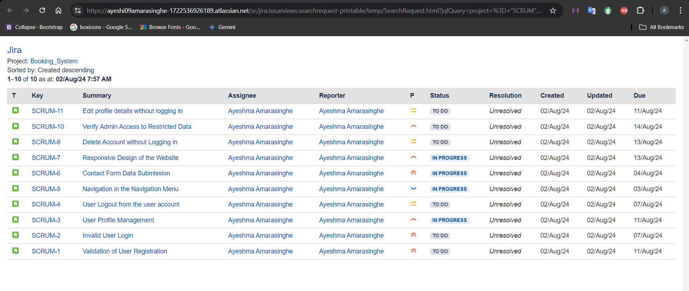

**TEST CASE 01 – Validation of User Registration**

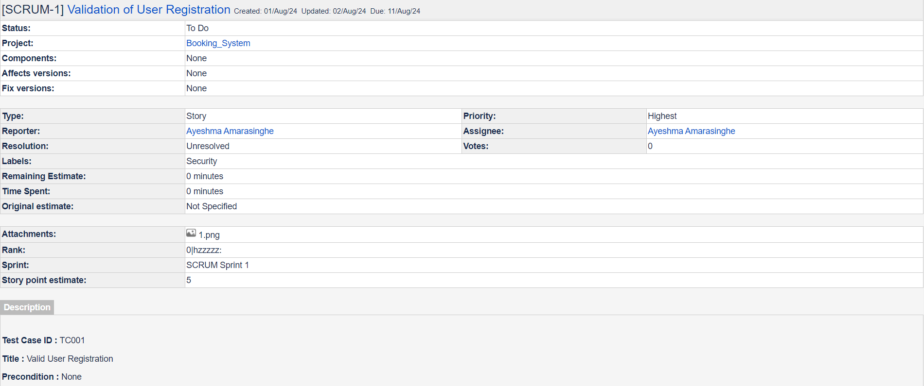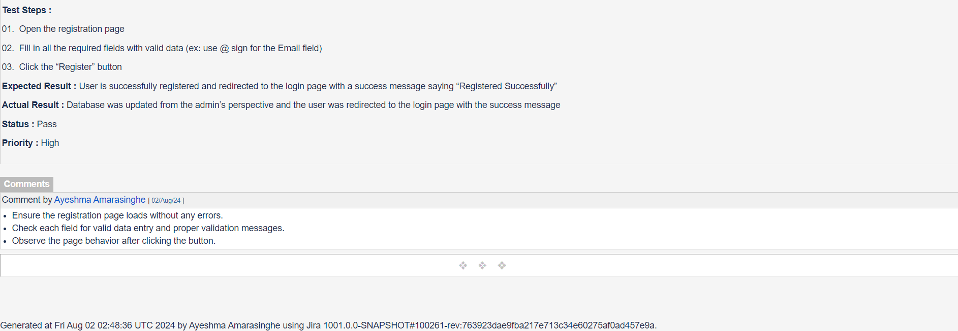

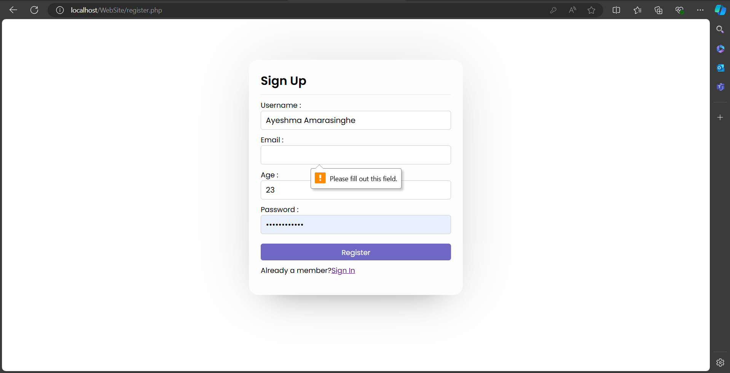

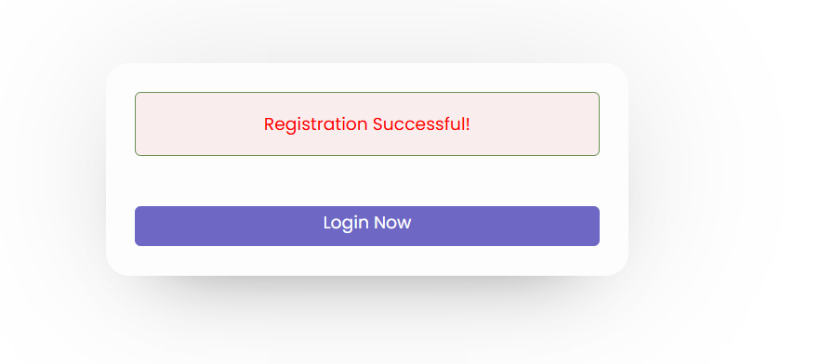

**TEST CASE 02 – Invalid User Login**

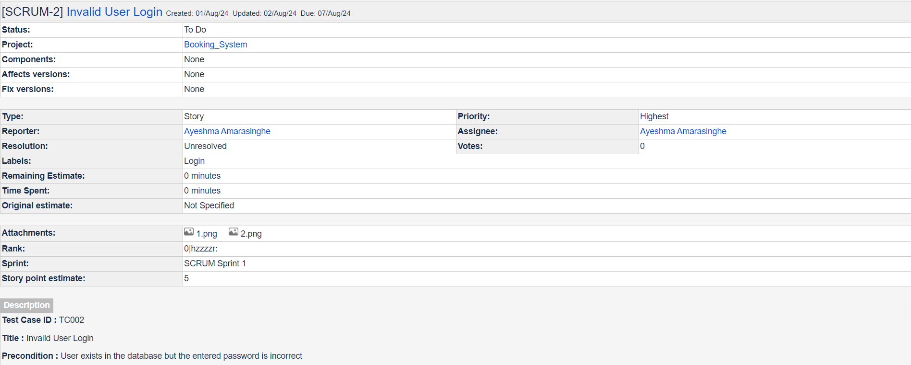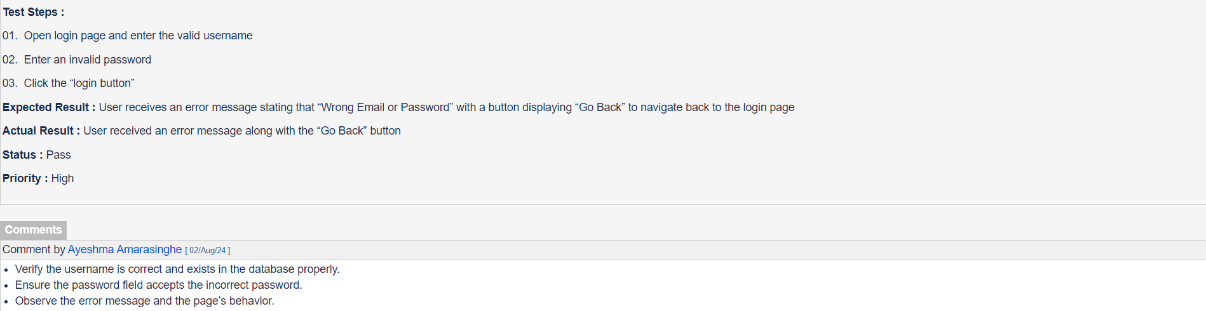

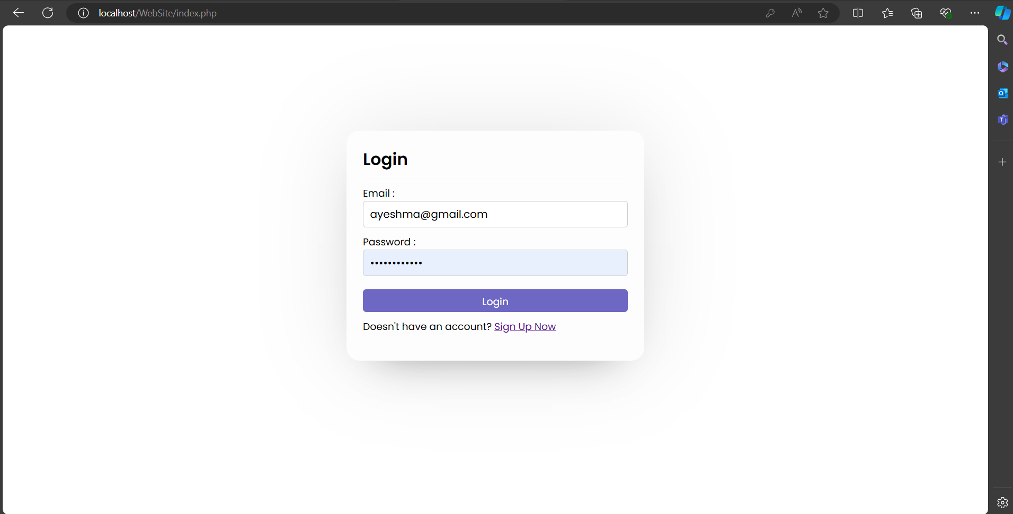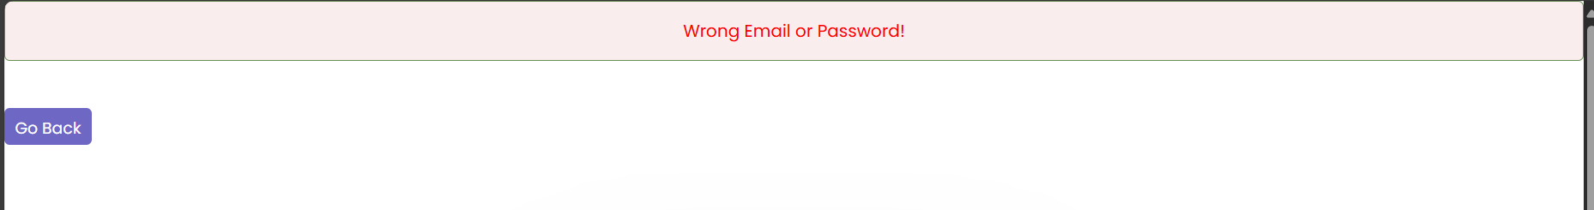

**TEST CASE 03 – User Profile Management**

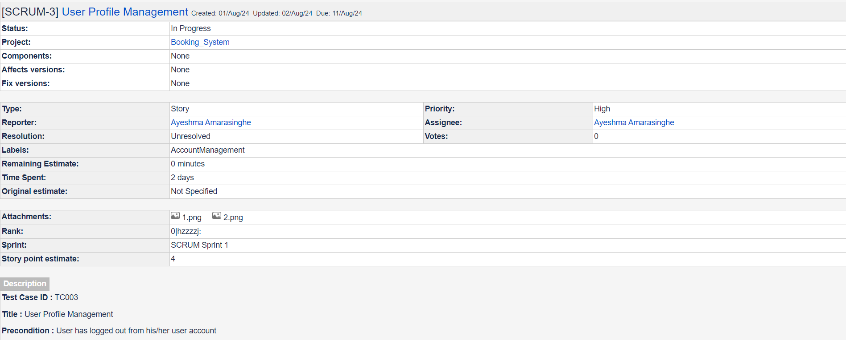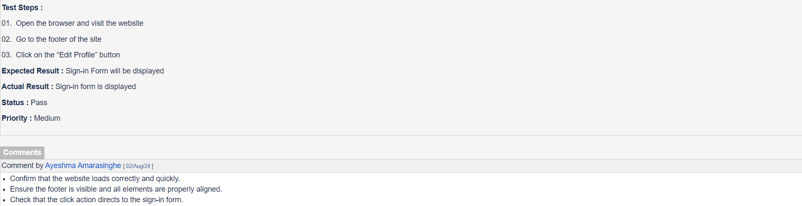

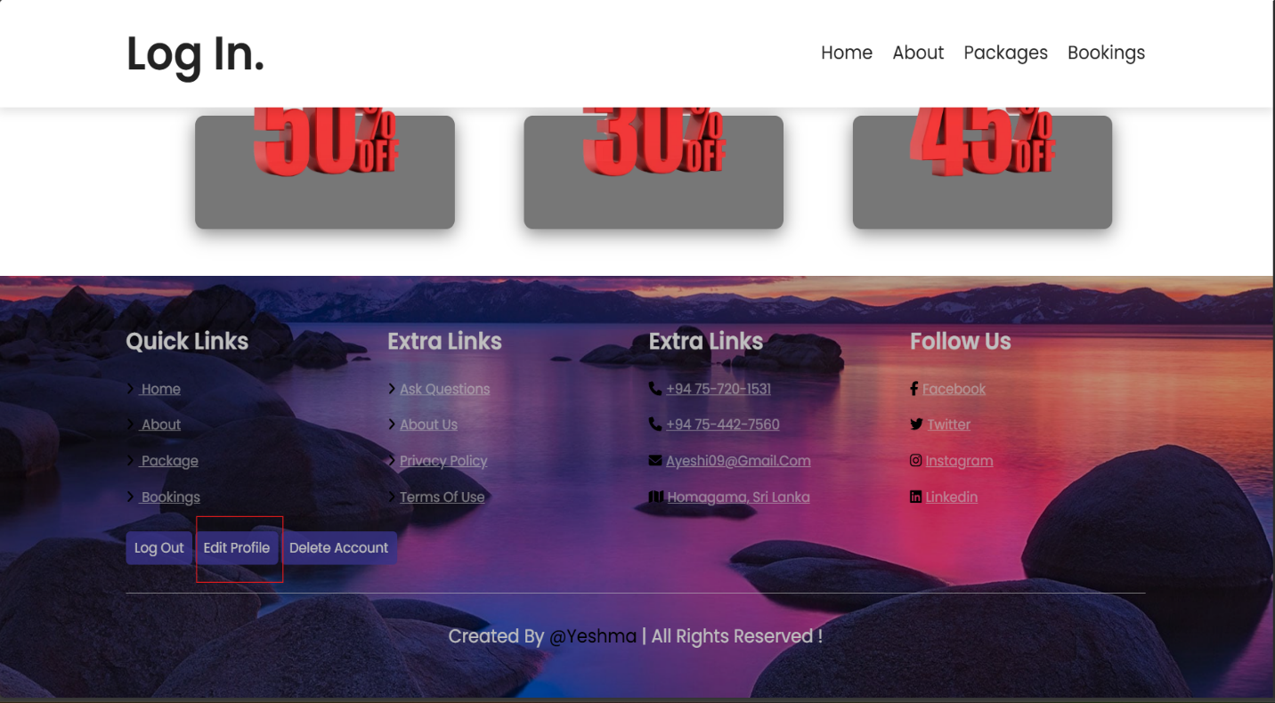

**TEST CASE 04 – User Logout from the User Account**

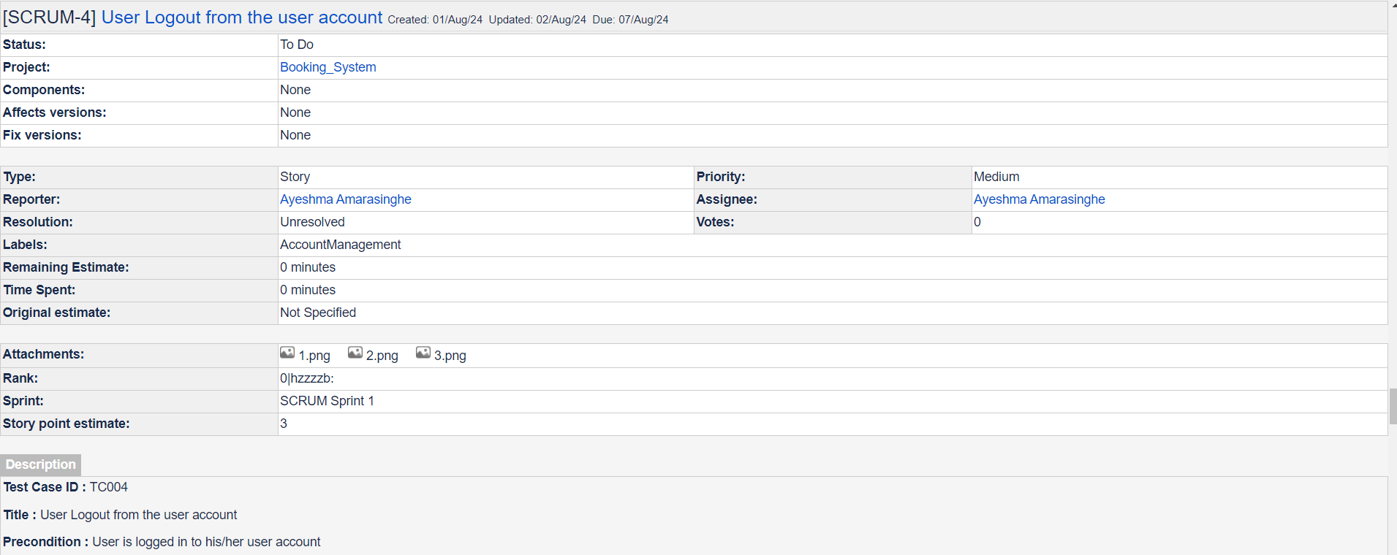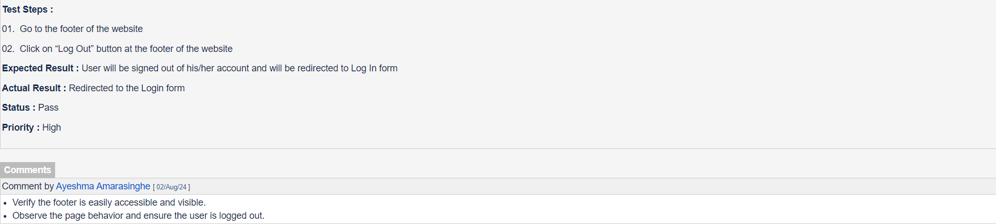

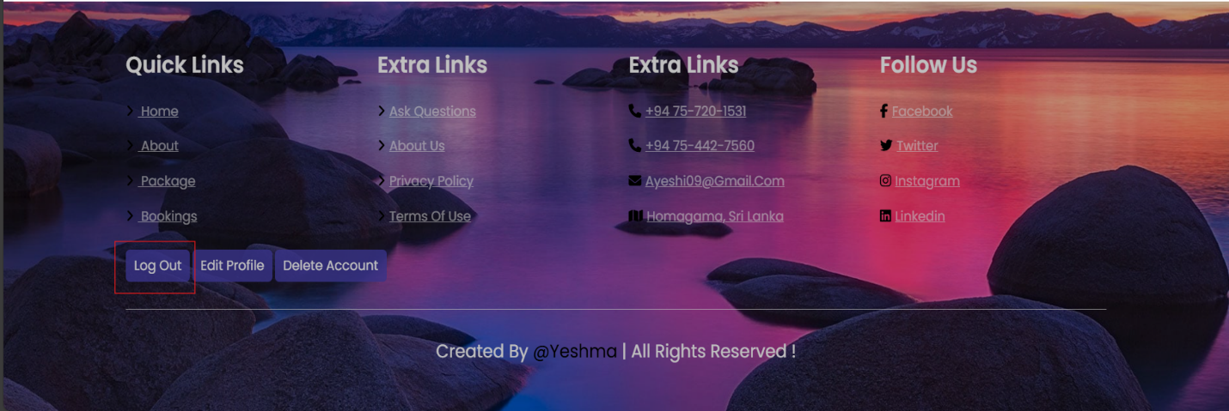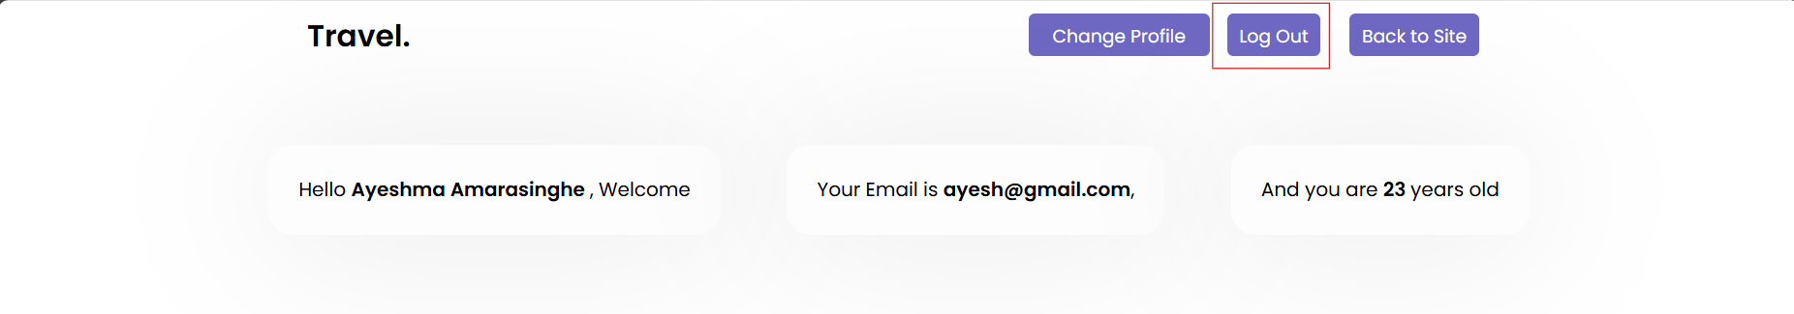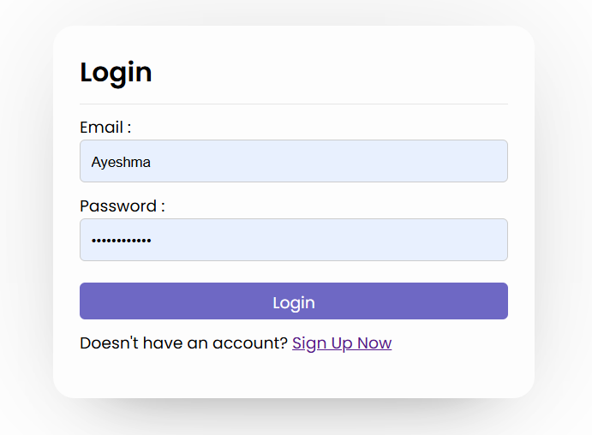

**TEST CASE 05 – Navigation in the Navigation Menu**

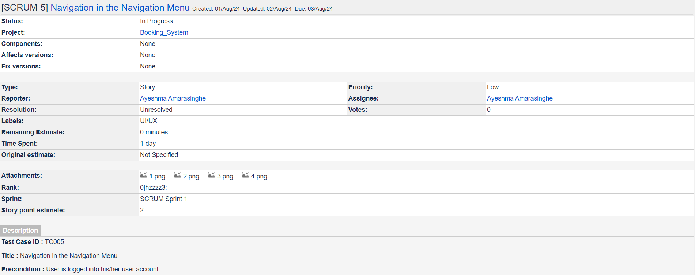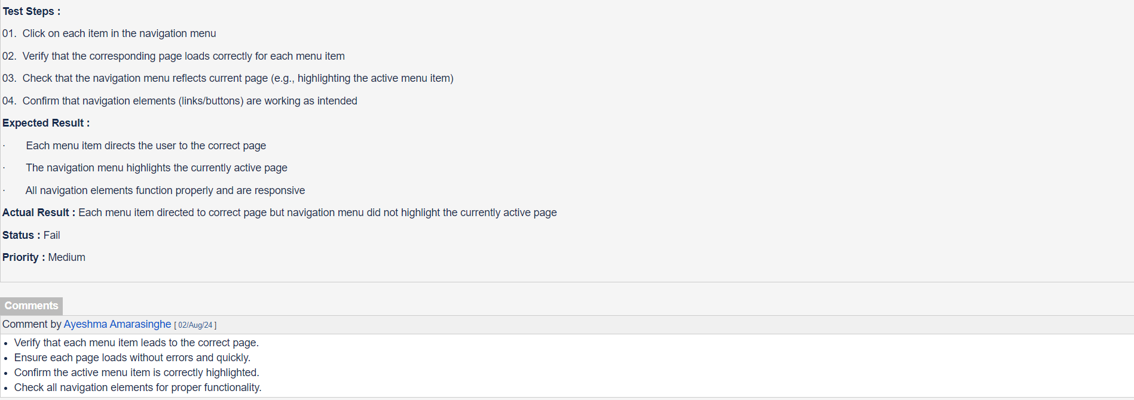



**TEST CASE 06 – Contact Form Data Submission**

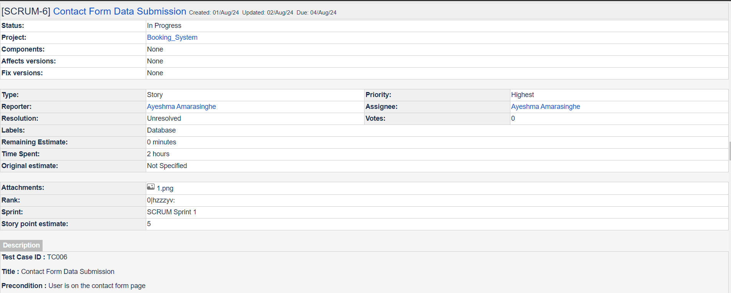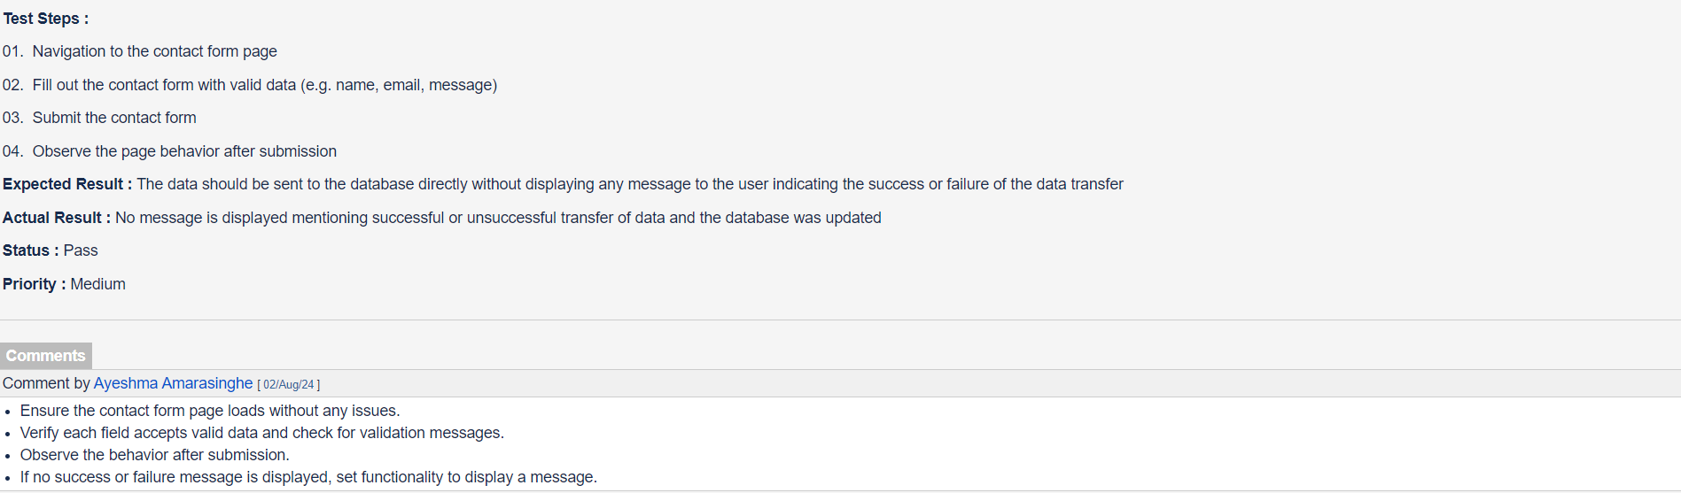

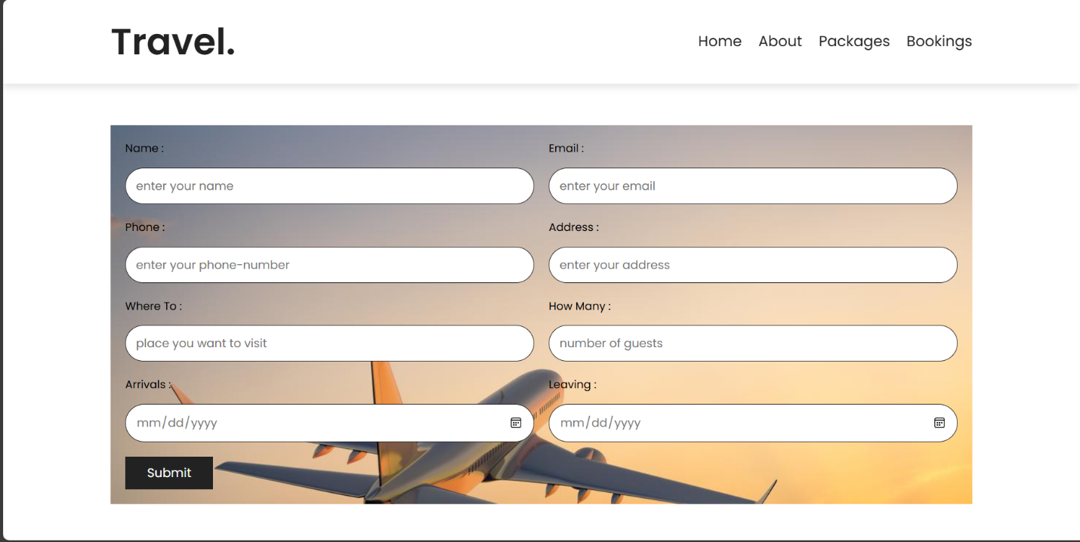

**TEST CASE 07 – Responsive Design of the Website**

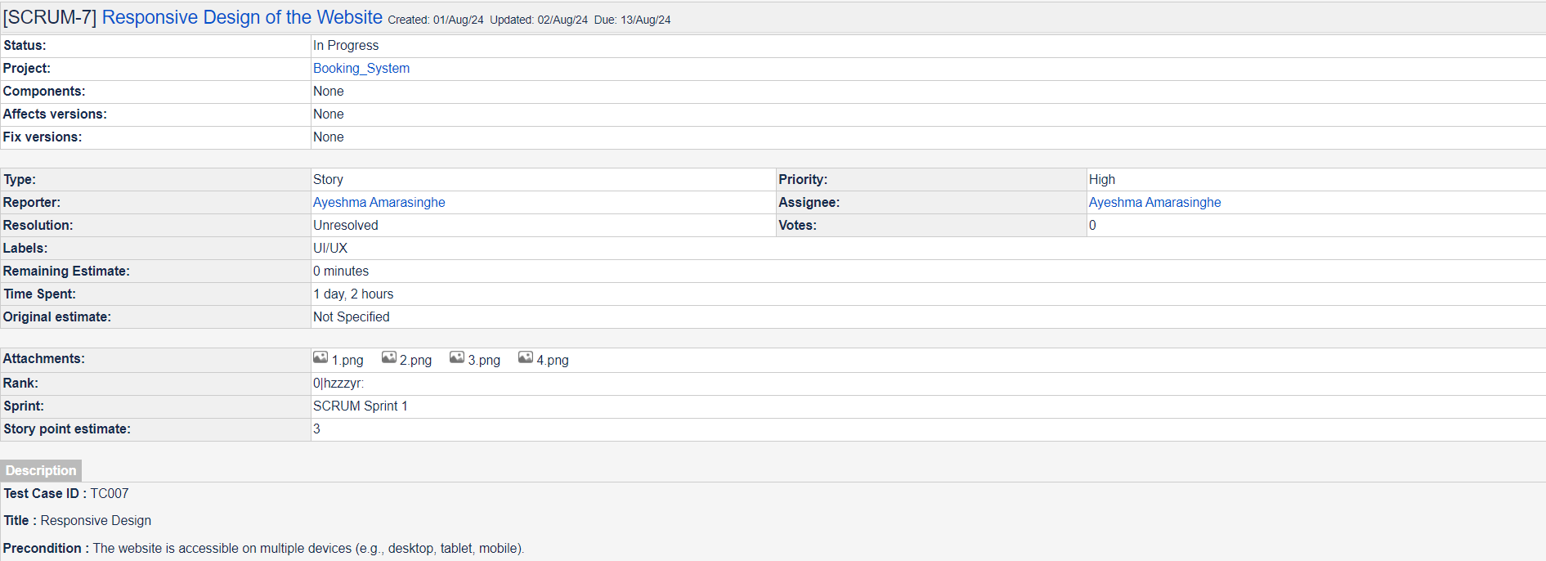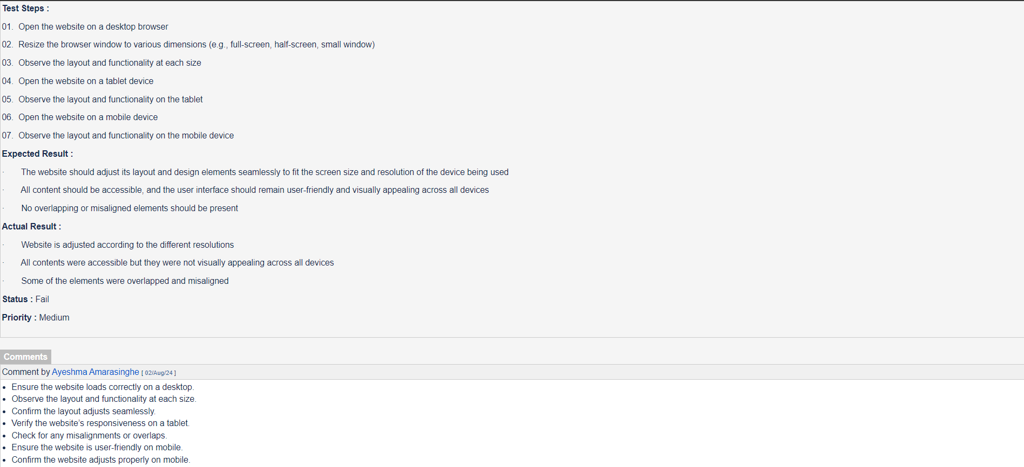

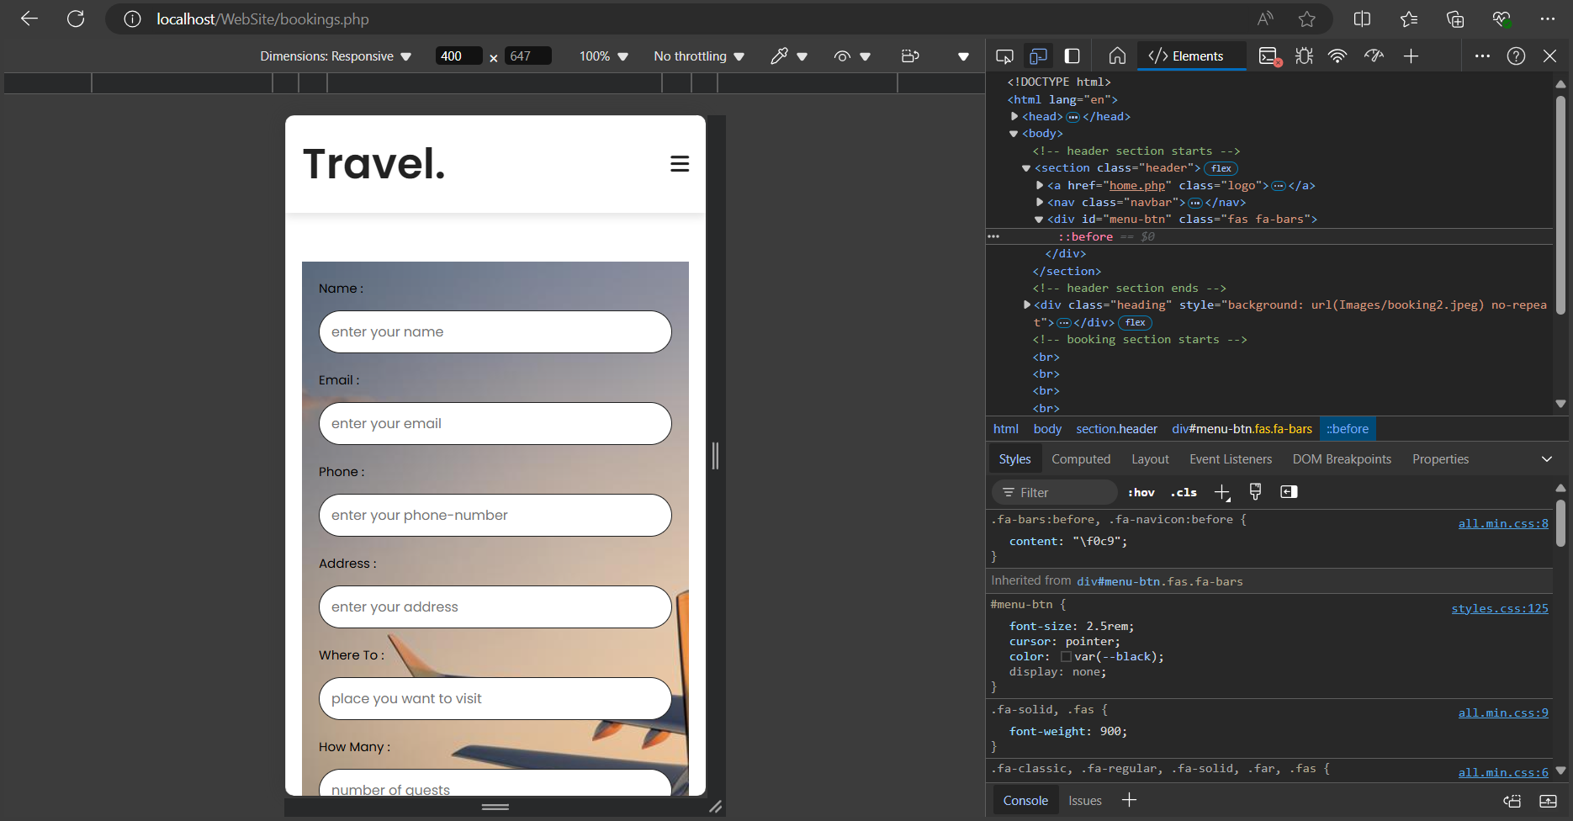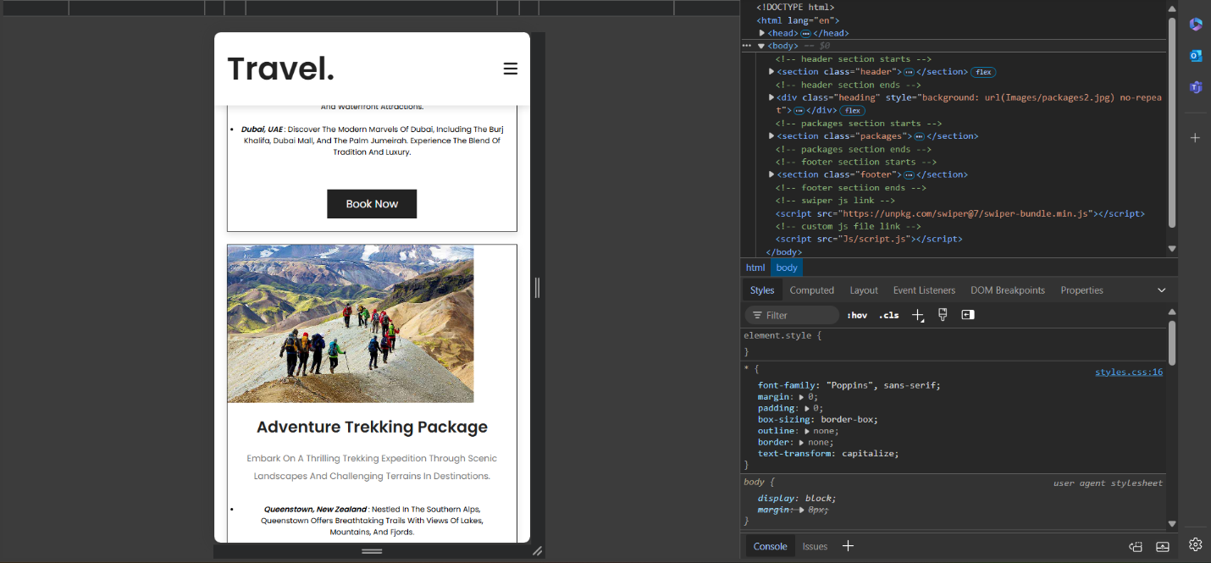

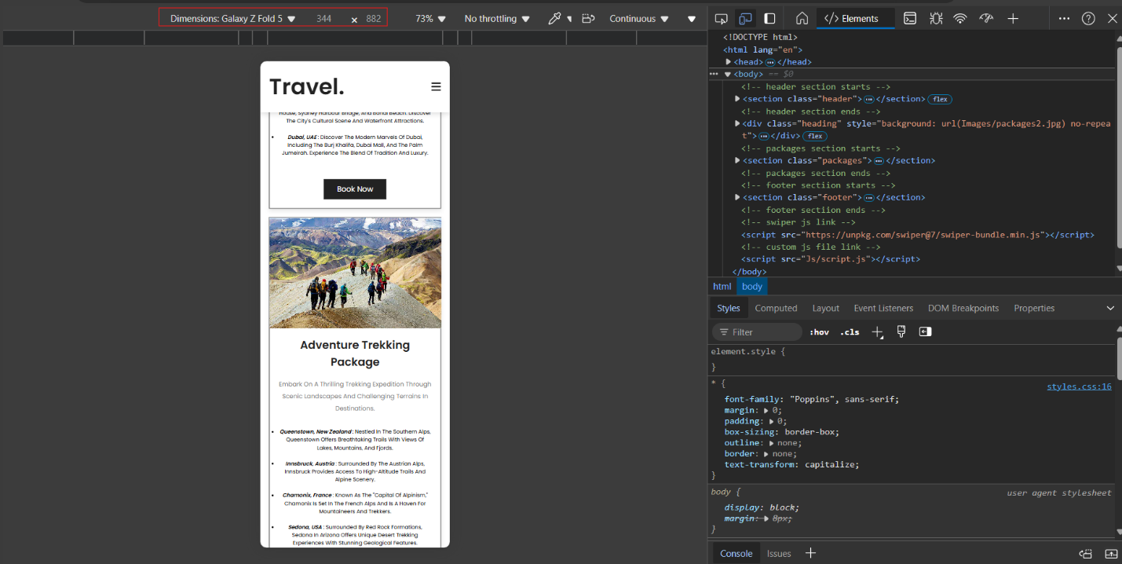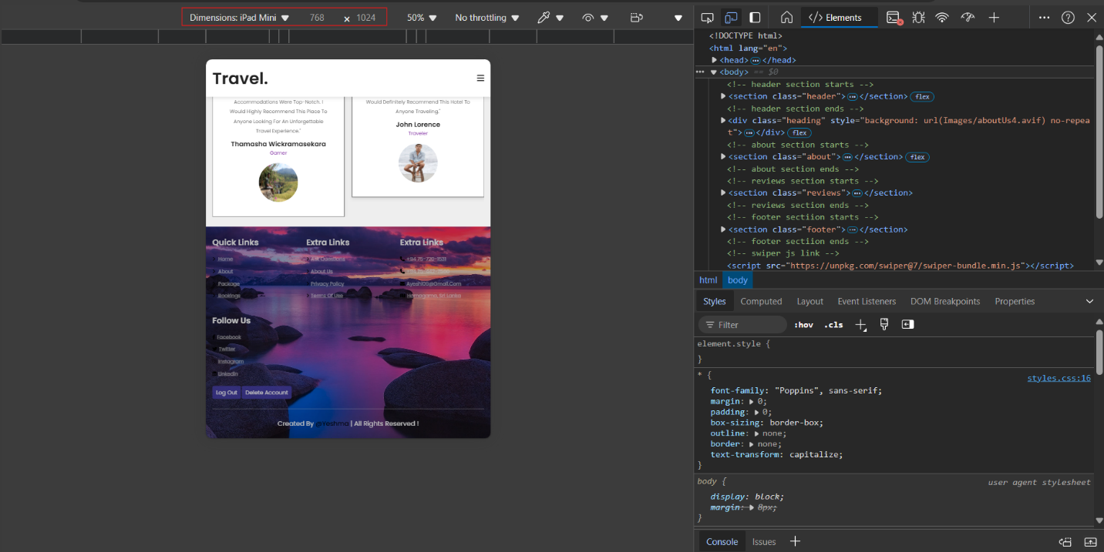

**TEST CASE 08 -Delete Account without Logging in**

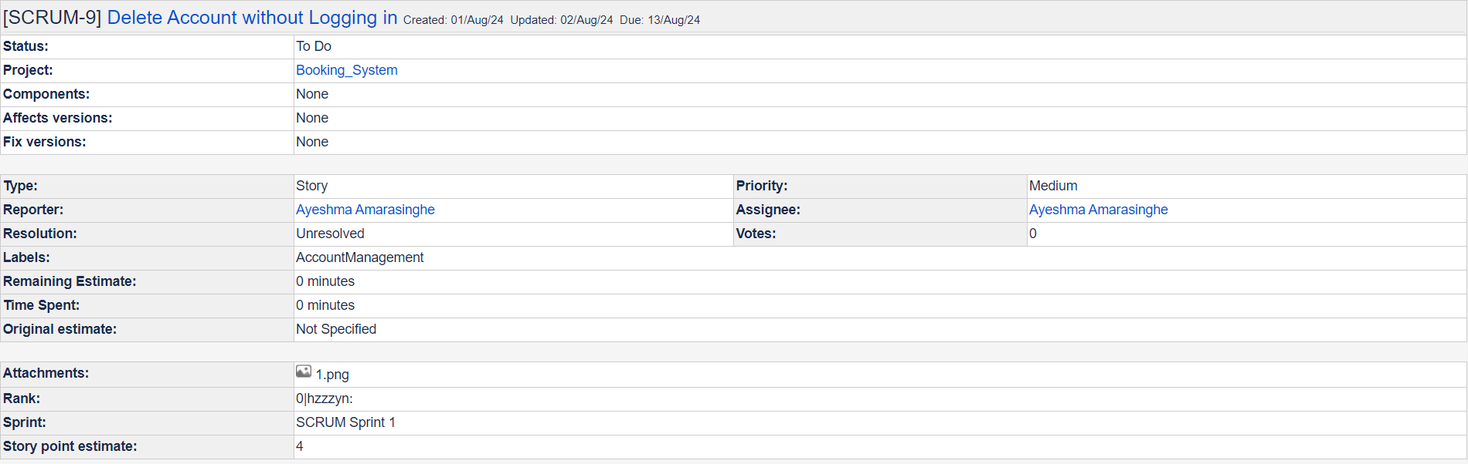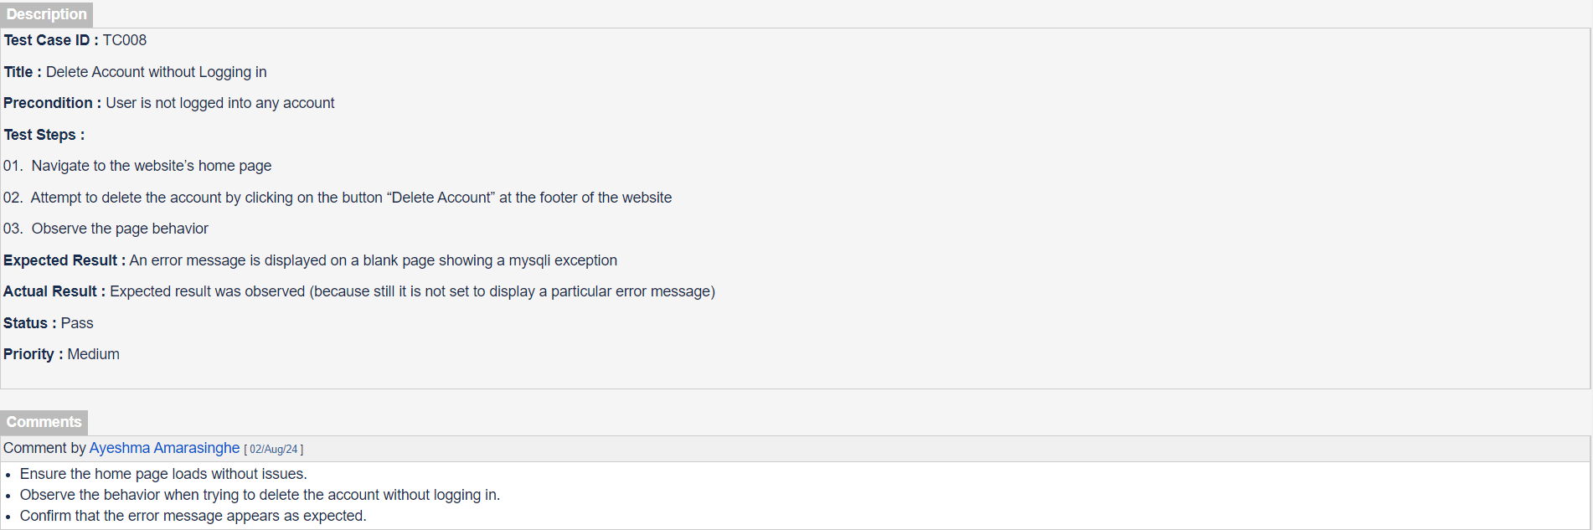

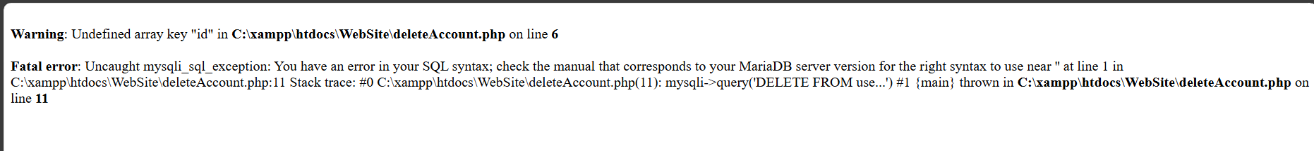

**TEST CASE 09 – Verify Admin Access to Restricted Data**

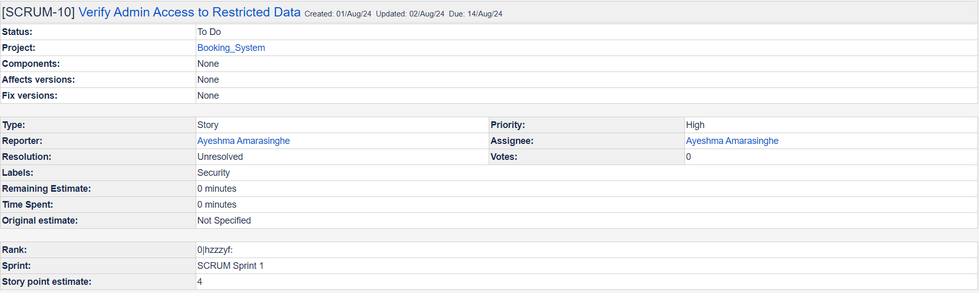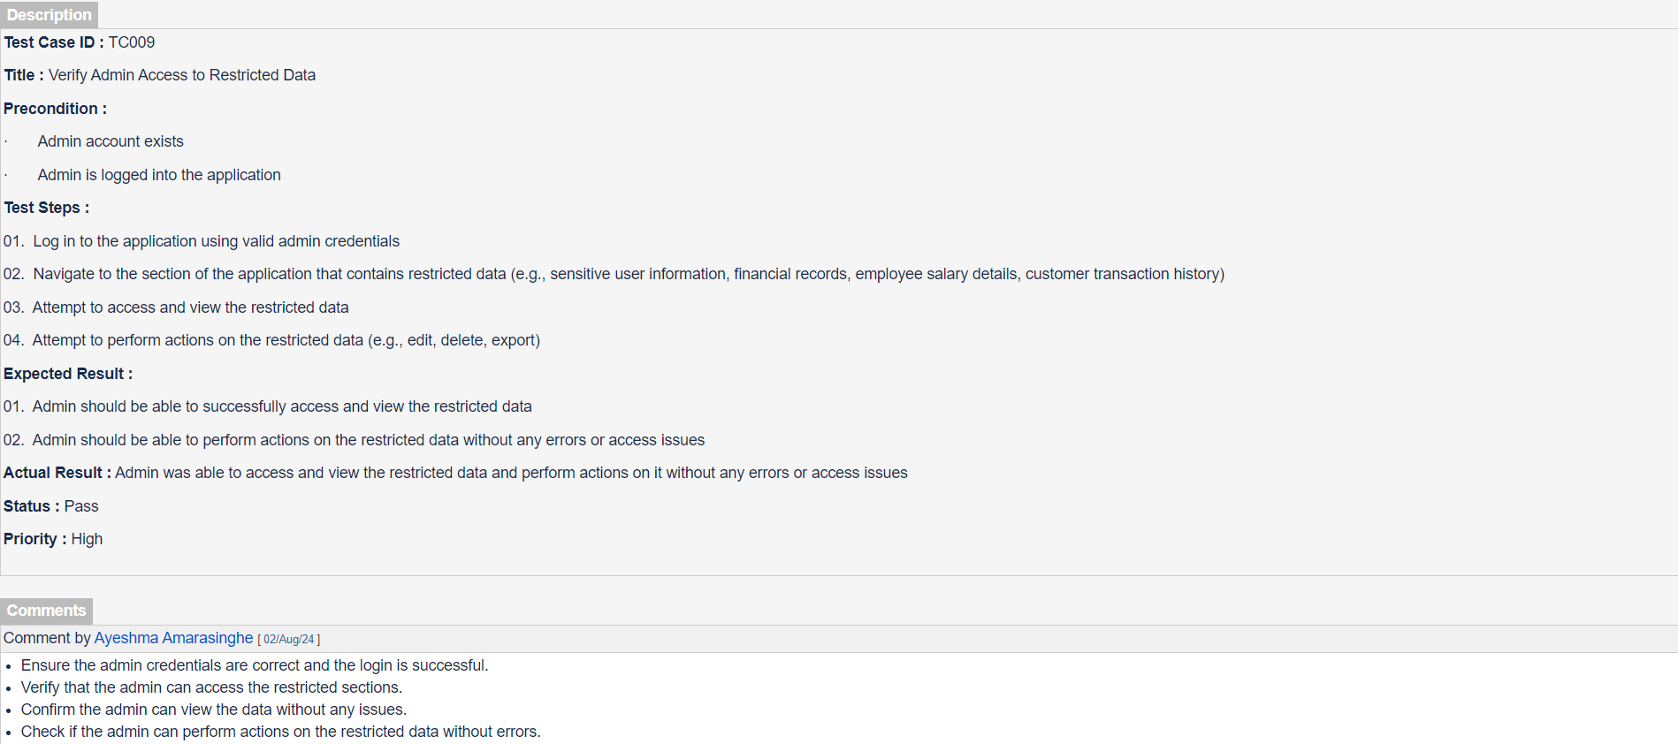

**TEST CASE 10 – Edit Profile details without Logging in**

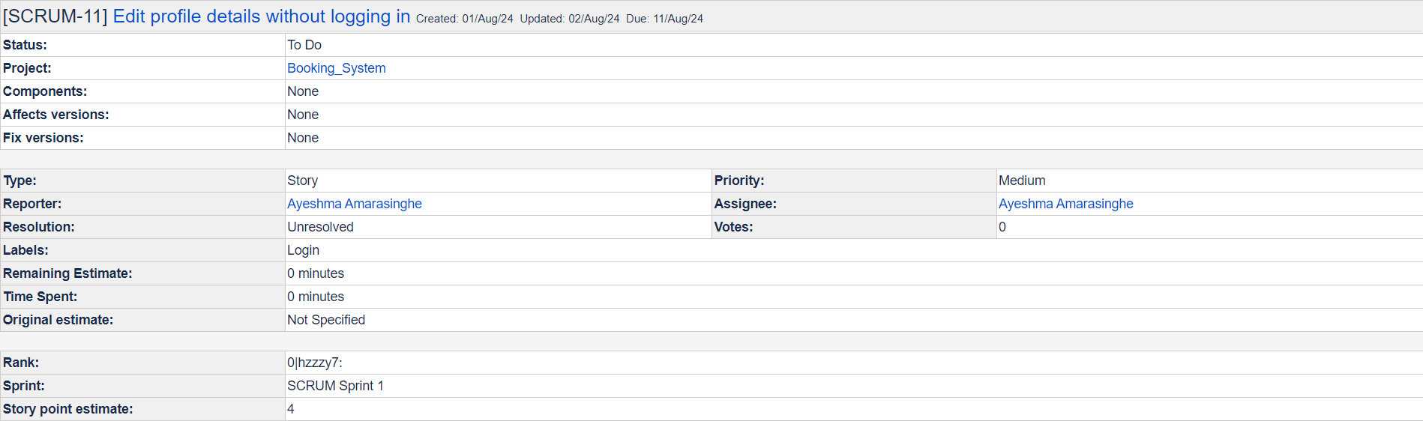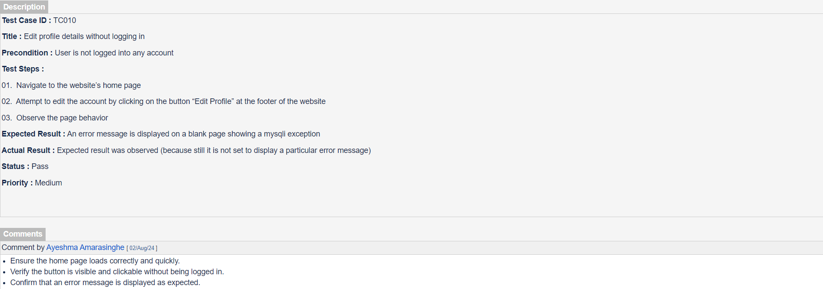

Unit Tests

* Sign Up

**TEST 01 – Check if user input data from register form goes to database without any problem**

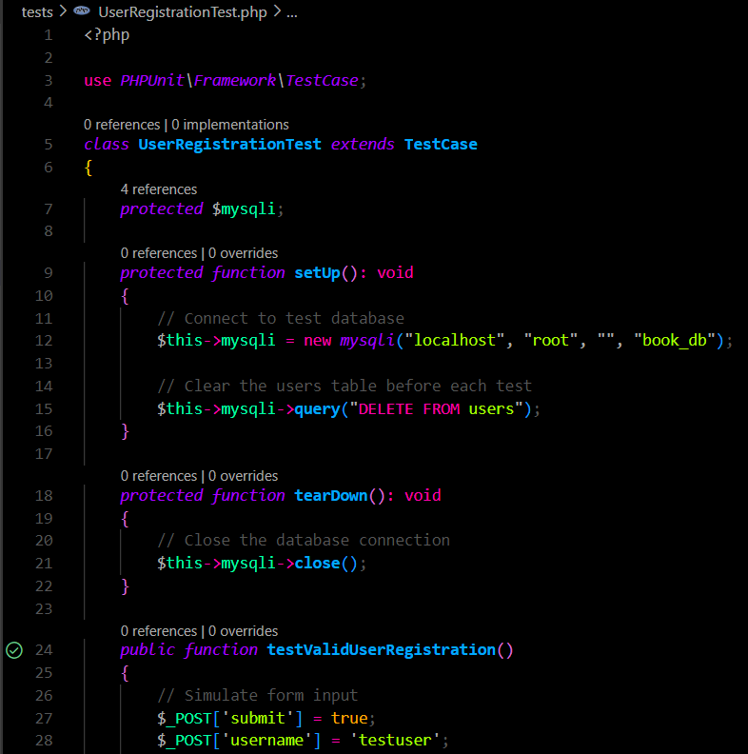

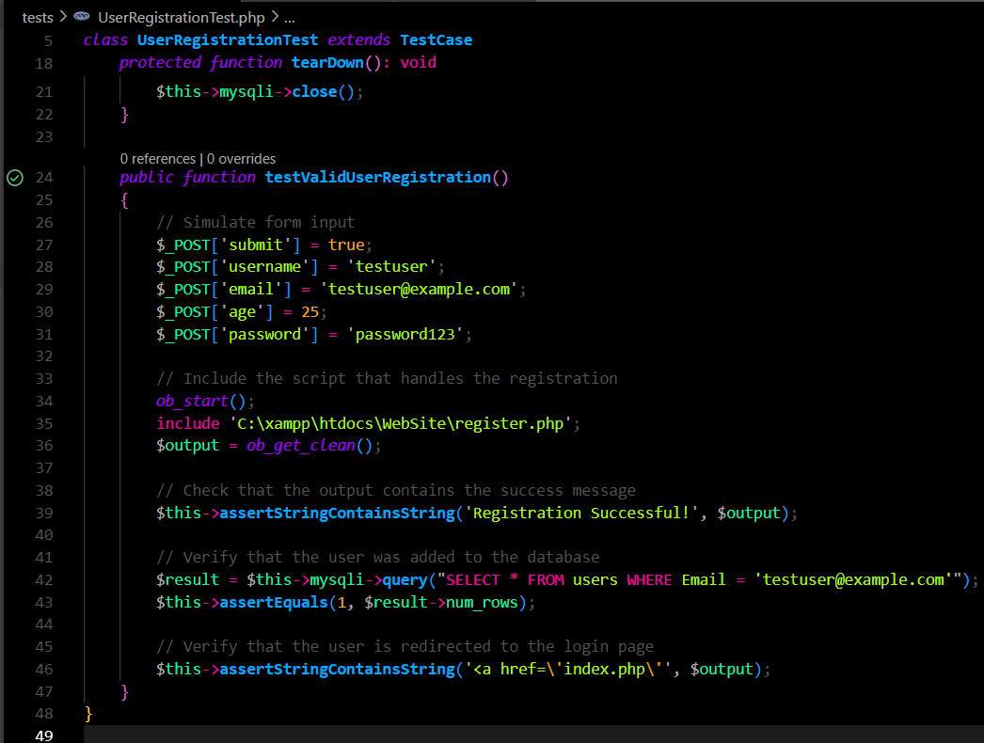

**Test Result :**

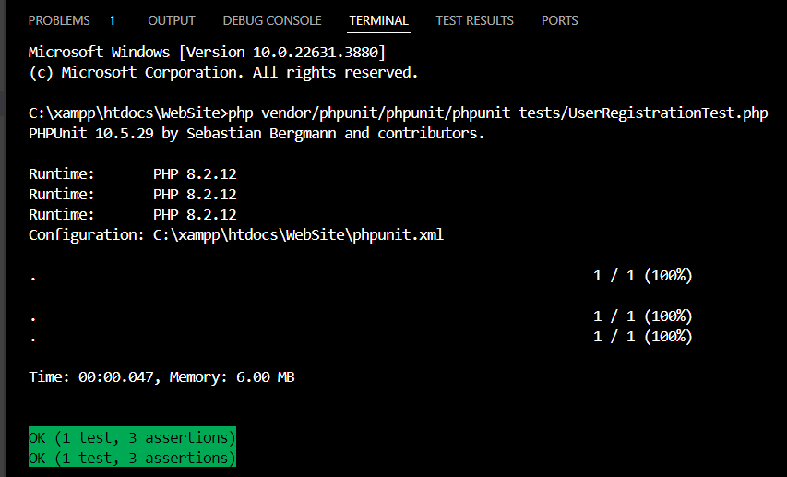

**TEST 02**

**Unique Email** - Check if one email is used for many accounts to register (unique email)

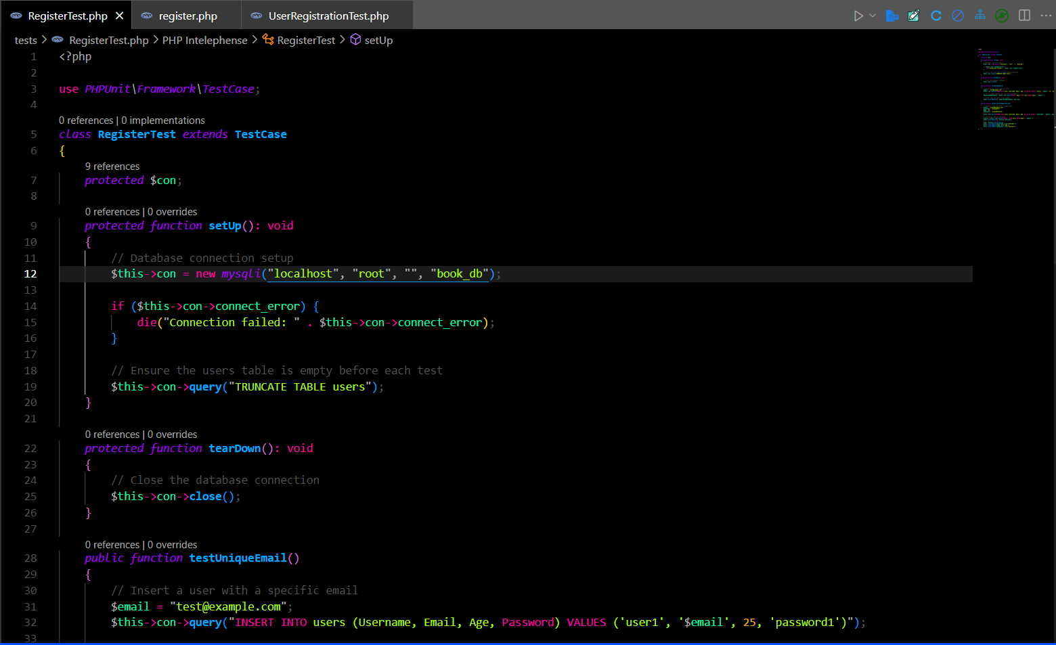

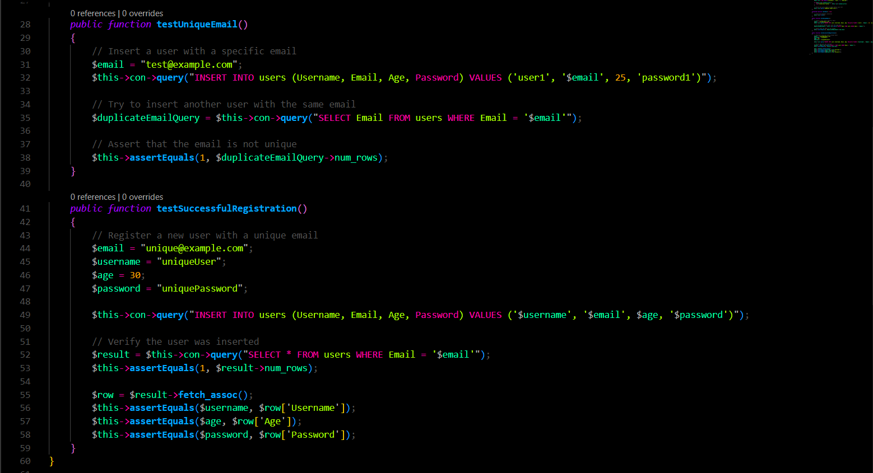

**Test Result :**

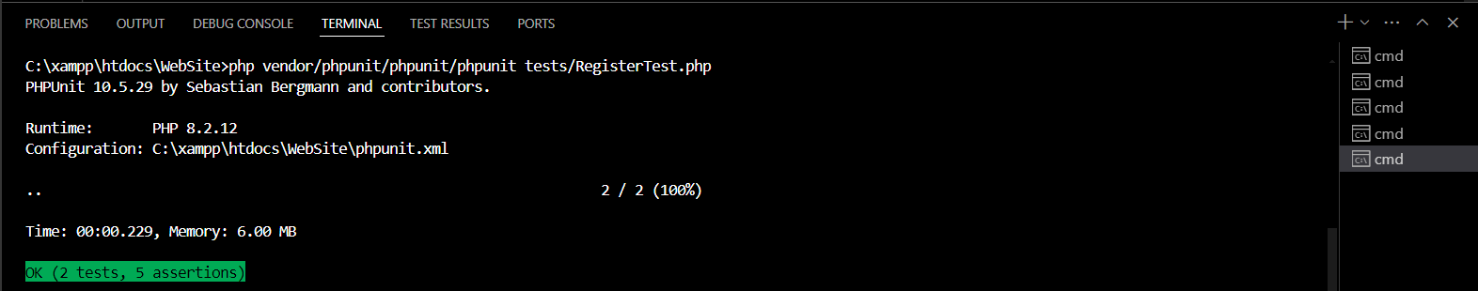

**TEST 03**

**Password Hashing –** If the password is hashed, terminal will give an error, if not test will be passed( I used this test because my database passwords are not hashed)

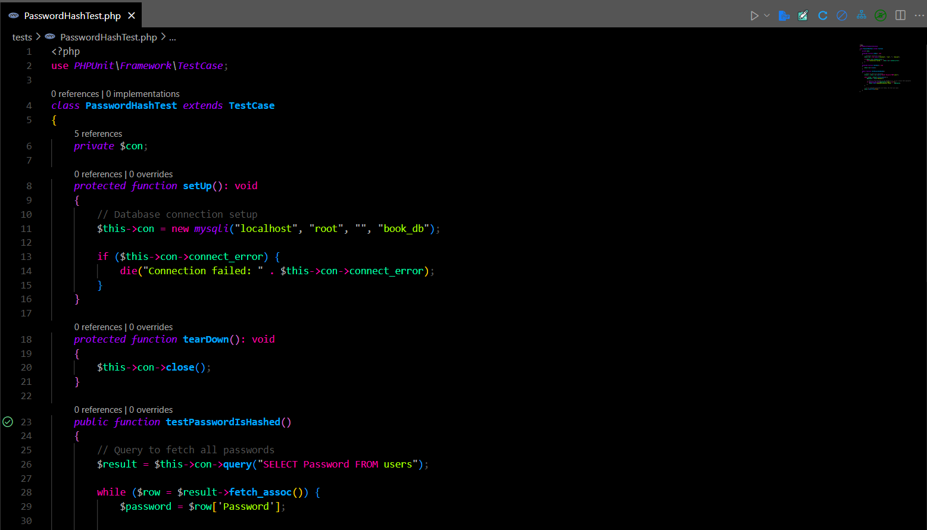

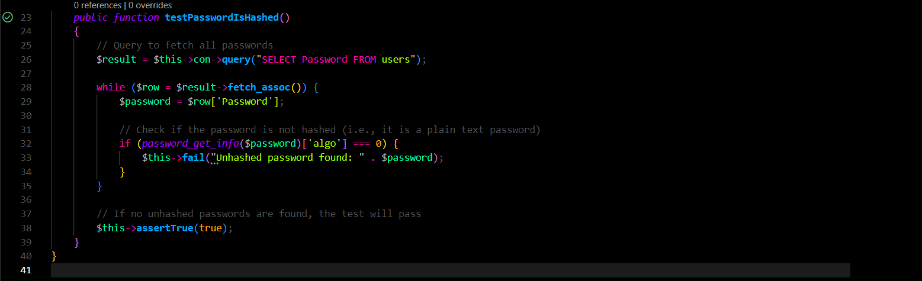

**Test Result :**

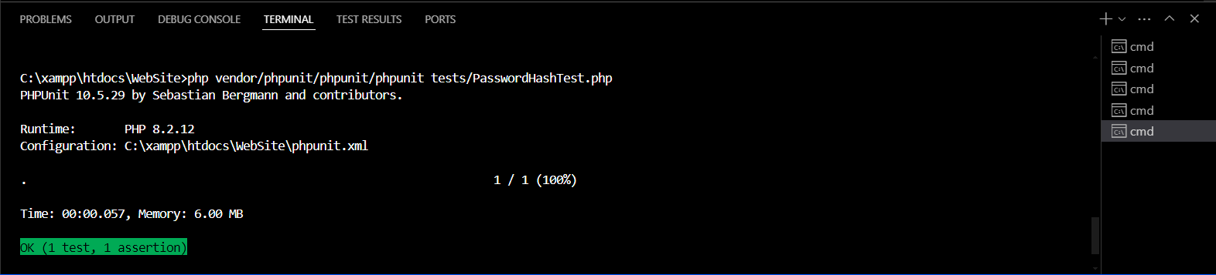

1. Raise Bugs and Create Task Tickets in JIRA:

**BUG 01 – Poor error handling through out the website**

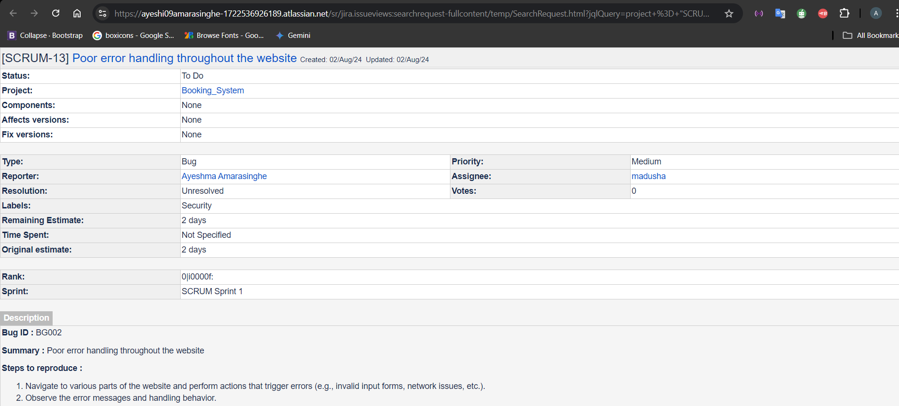

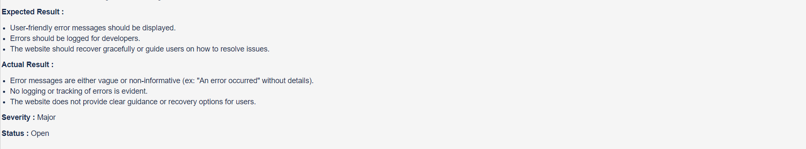

**BUG 02 – Responsive Design of the Website**

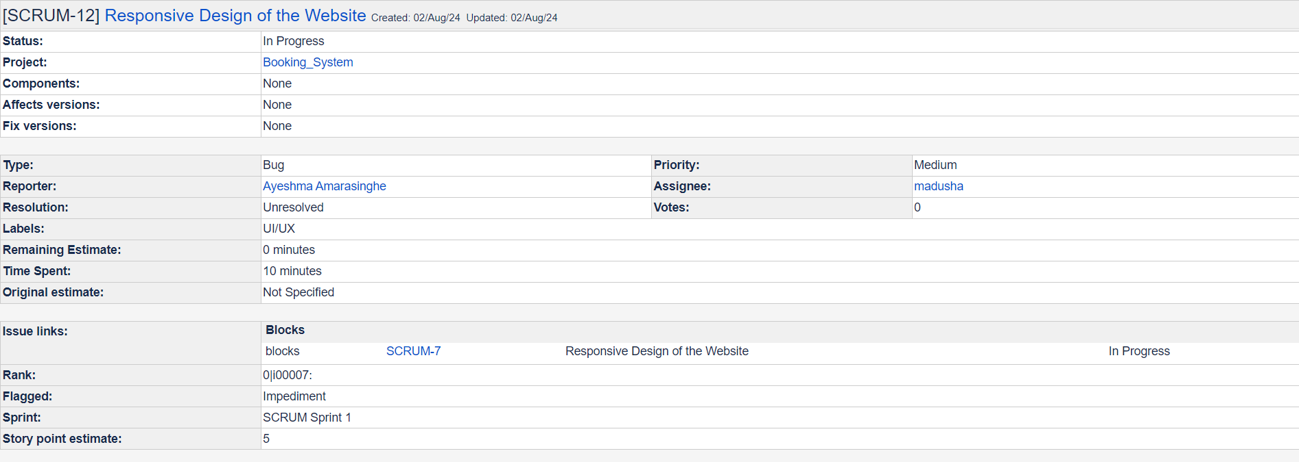

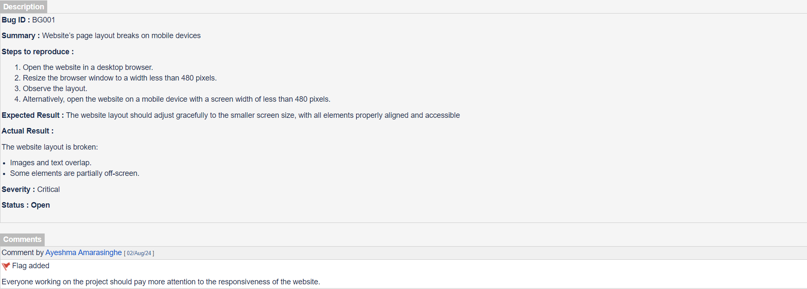

1. Automation of Specific Flows:

**TEST 01 – Book form Test**

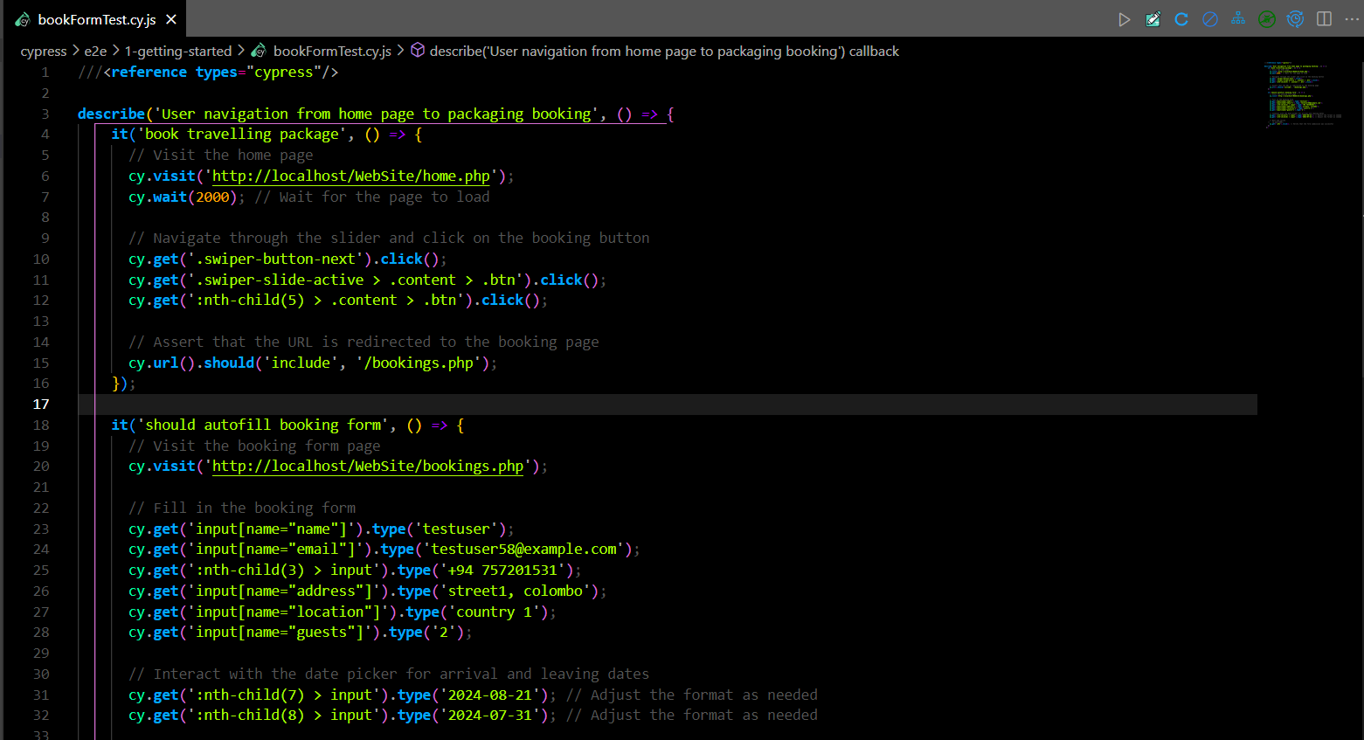

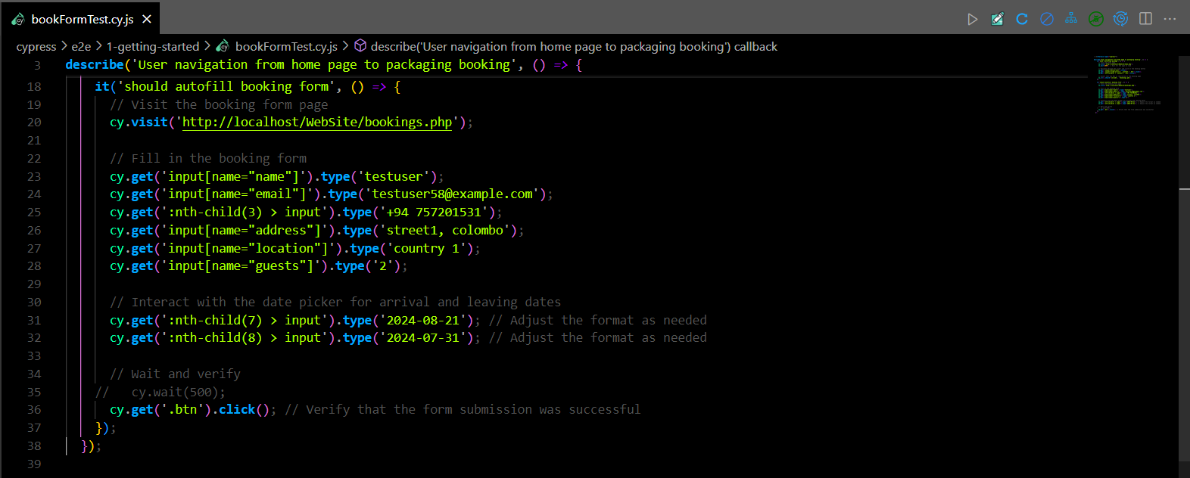

**TEST 02 – User registration Test**

* Using an used Email

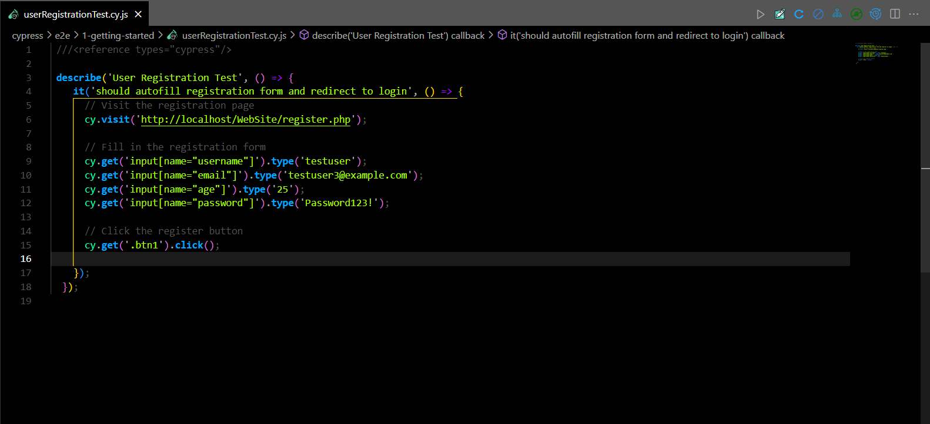

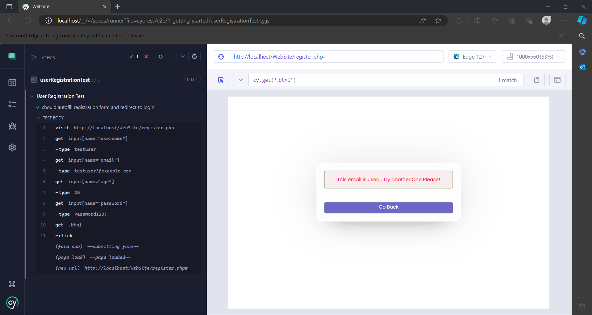

* Using an unique Email

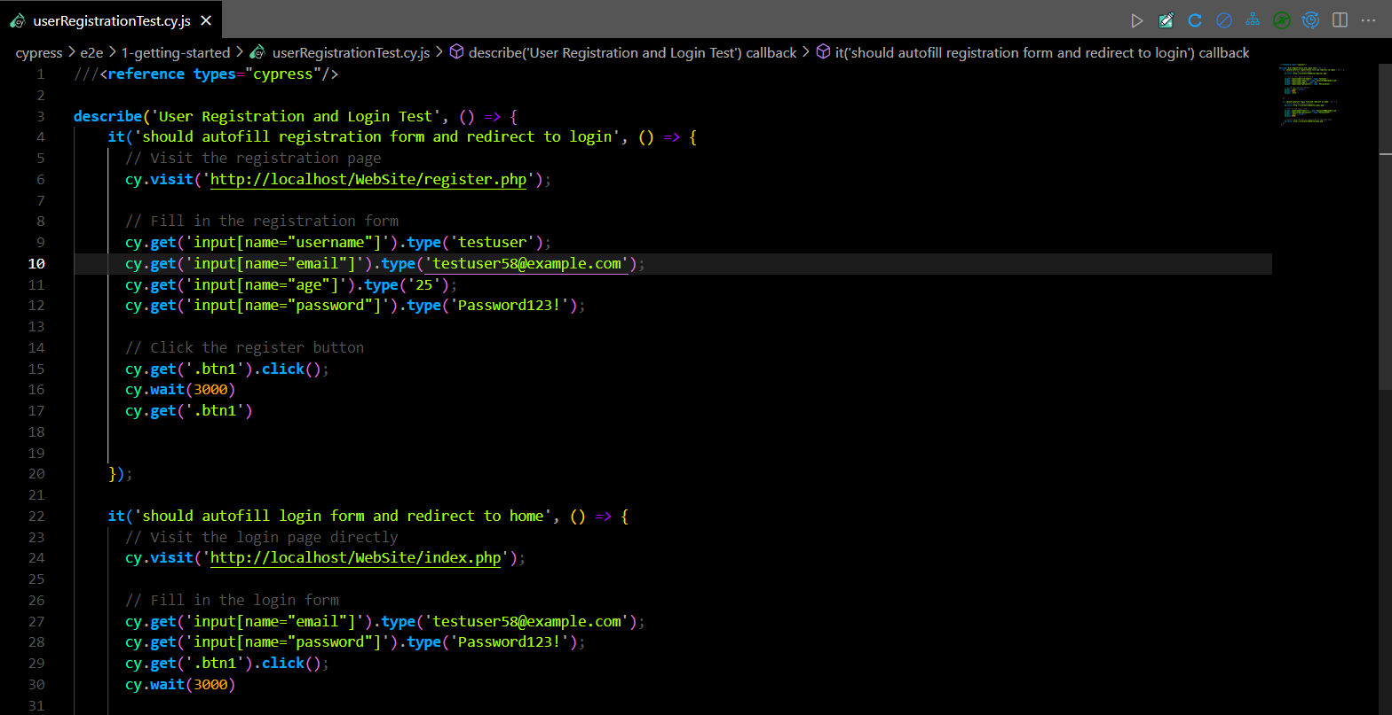

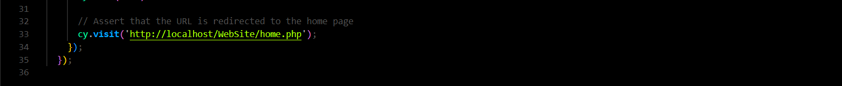

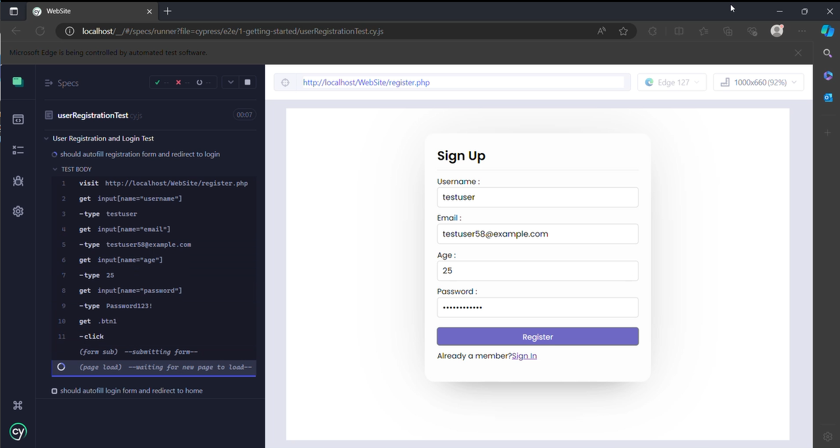

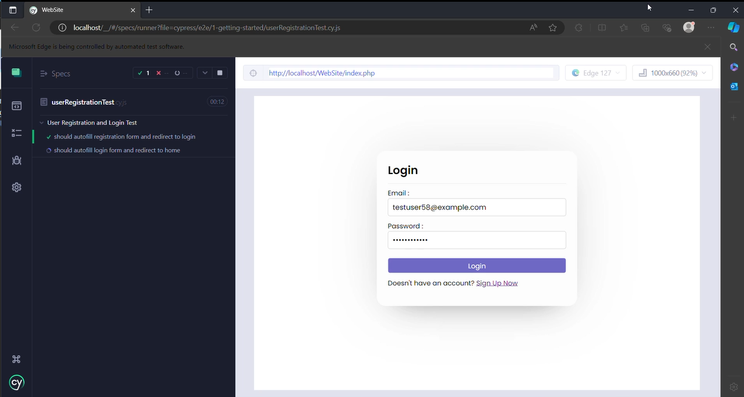

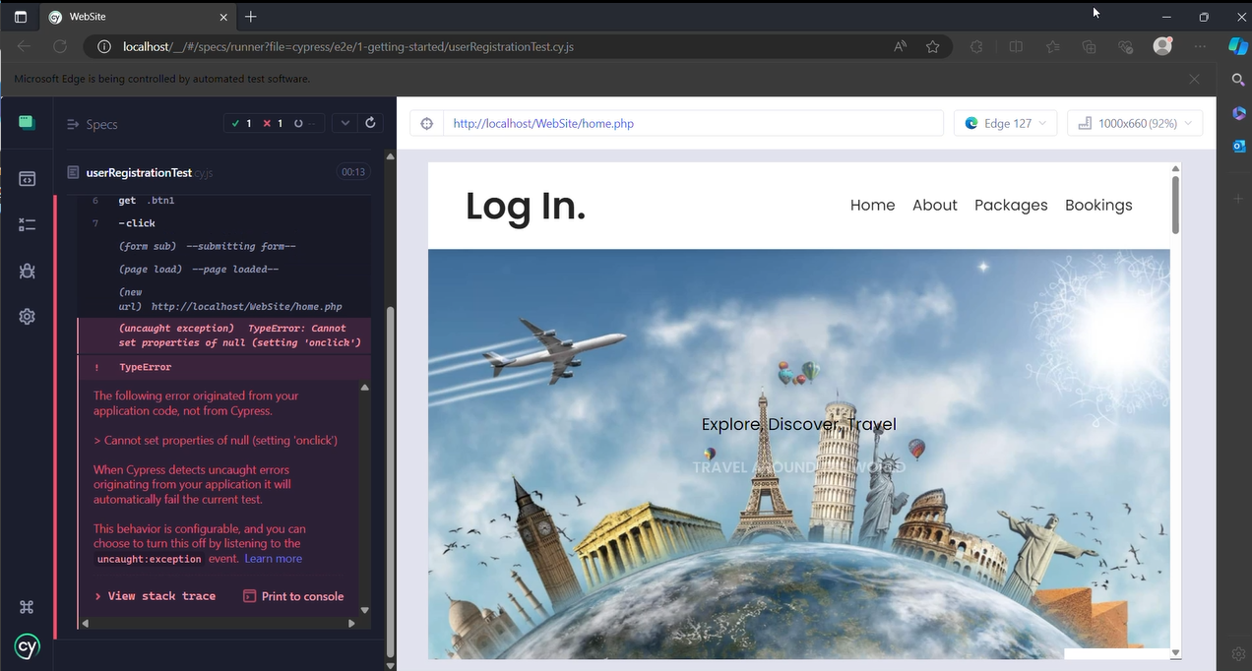

**NOTE :**

* Error shown above was due to an exception caused in the main Js file but not due to some error occurred due to the testing process
* Testing process will be posted as a video in Git Repository

1. Performance Testing:

**TEST 01 – Change Profile Test**

|  |  |
| --- | --- |
| **Test Scenario** | **Multiple Users Change Profile details simultaneously to the system** |
| **Test Data** | **Name:** testUser  **Email:** [**tester@gmail.com**](mailto:tester@gmail.com)  **Age :** 23 |
| **Response Time** | 37ms |
| **Throughput** | 13.6/min |
| **Expected Result** | **Response Time:** 35ms – 40ms  **Throughput:** 12/min – 15/mi**n**  **Error Rate:** 0%  **Latency:** 20ms – 25ms |
| **Actual Result** | **Response Time:** 37ms  **Throughput:** 13.6/min  **Error Rate:** 0%  **Latency:** 21ms |

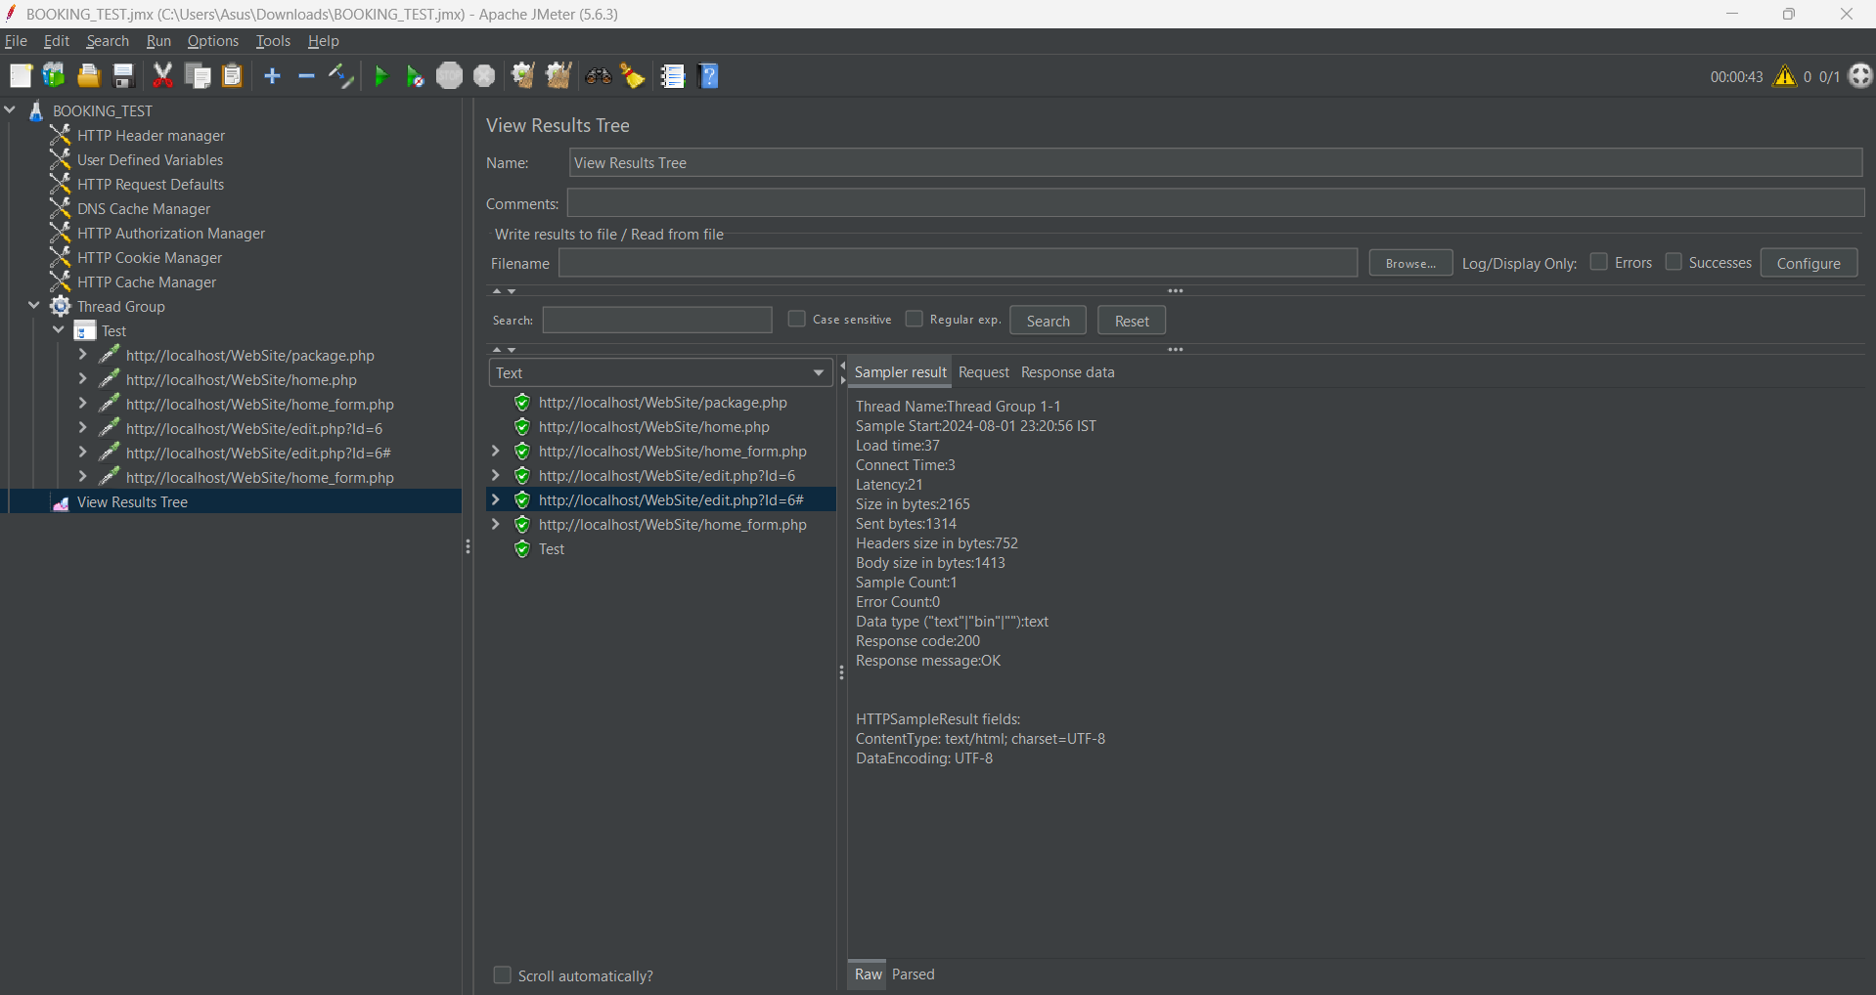

**Test Summary**

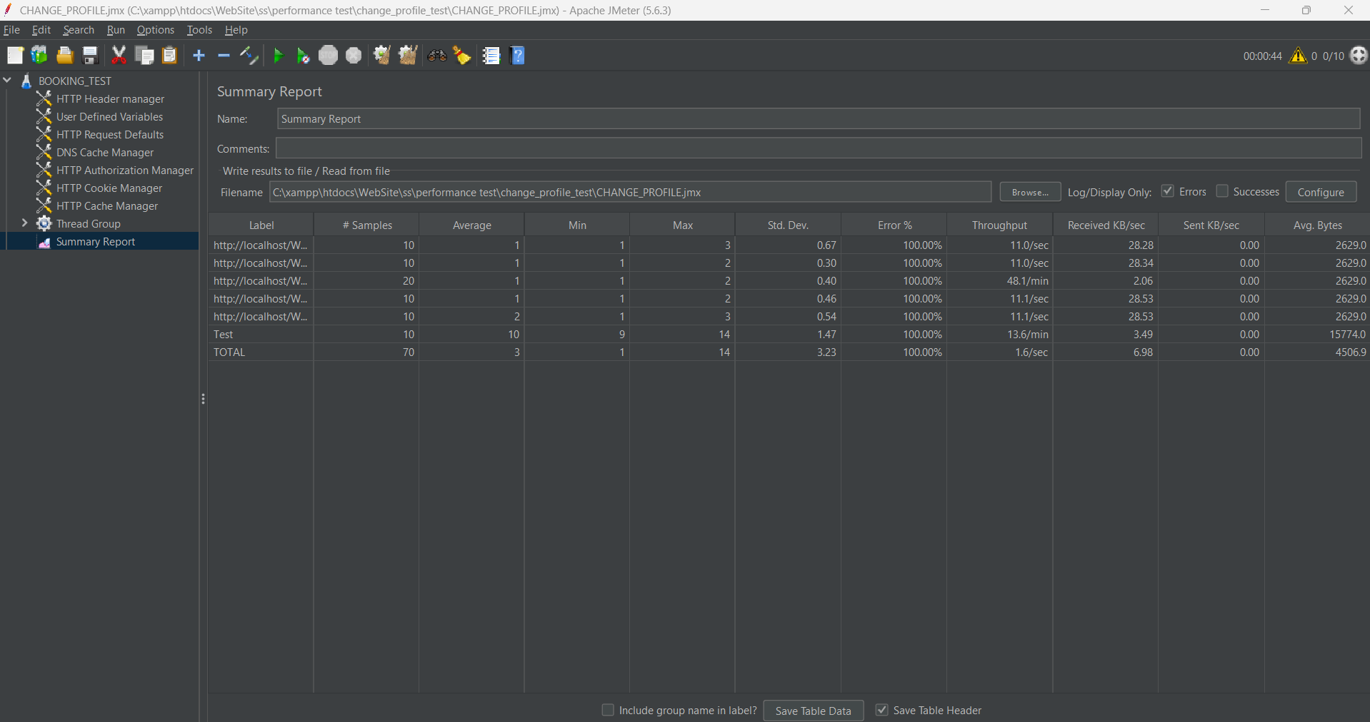

**TEST 02 – Login Test**

|  |  |
| --- | --- |
| **Test Scenario** | **Multiple Users log in to the system simultaneously** |
| **Test Data** | **Email:** [**tester@gmail.com**](mailto:tester@gmail.com)  **Password:** password123! |
| **Response Time** | 36ms |
| **Throughput** | 500.0/sec |
| **Expected Result** | **Response Time:** 35ms – 40ms  **Throughput:** 600.0/sec  **Error Rate:** 0%  **Latency:** 30ms – 40ms |
| **Actual Result** | **Response Time:** 36ms  **Throughput:** 500.0/sec  **Error Rate:** 0%  **Latency:** 36ms |

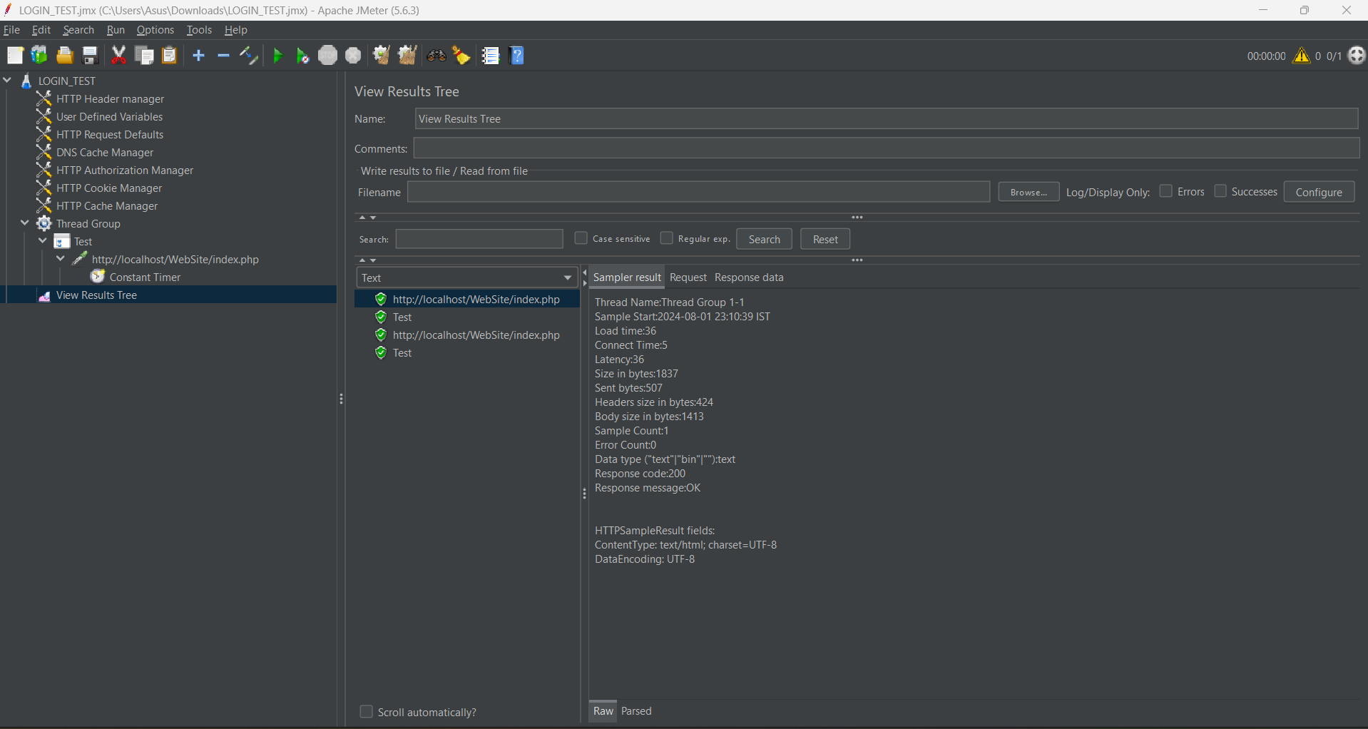

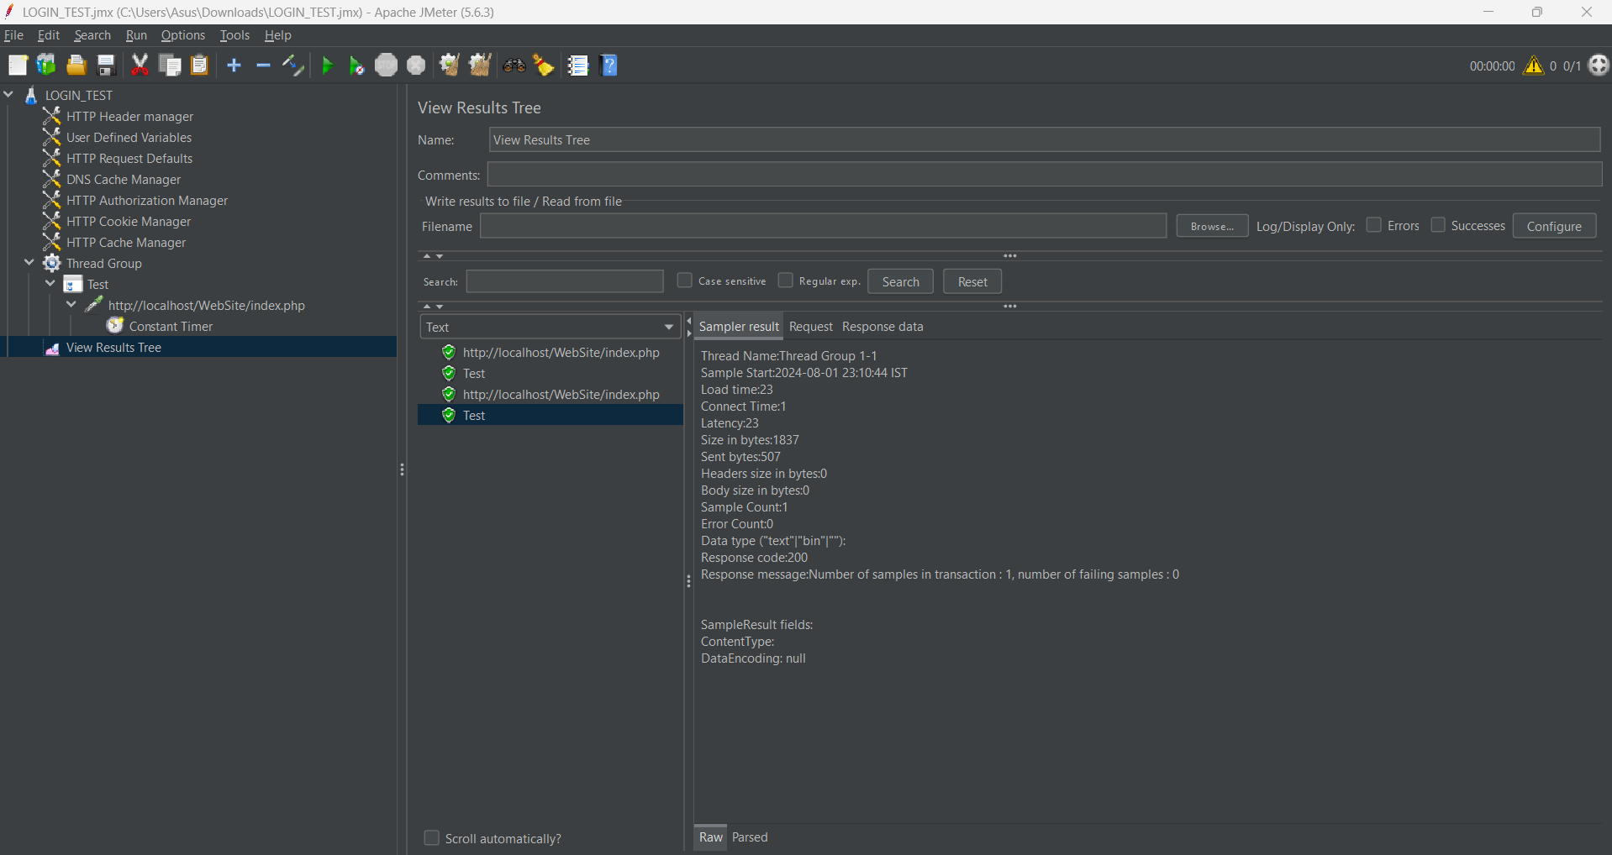

**Test Summary :**

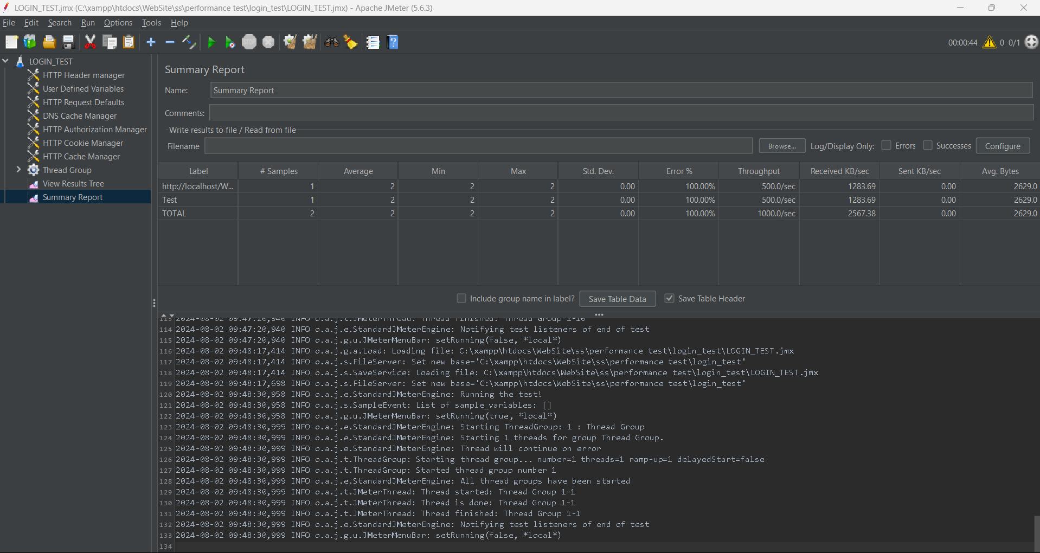

**TEST 03 – Signup Test**

|  |  |
| --- | --- |
| **Test Scenario** | **Multiple Users sign up to the system simultaneously** |
| **Test Data** | **Username:** testUser  **Email:** [**tester@gmail.com**](mailto:tester@gmail.com)  **Age:** 23  **Password:** password123! |
| **Response Time** | 60ms |
| **Throughput** | 6.1/min |
| **Expected Result** | **Response Time:** < 62ms  **Throughput**: 60/min  **Error Rate**: 0%  **Latency**: 60ms – 70ms |
| **Actual Result** | **Response Time:** 60ms  **Throughput:** 6.1/min  **Error Rate**: 0%  **Latency:** 62ms |

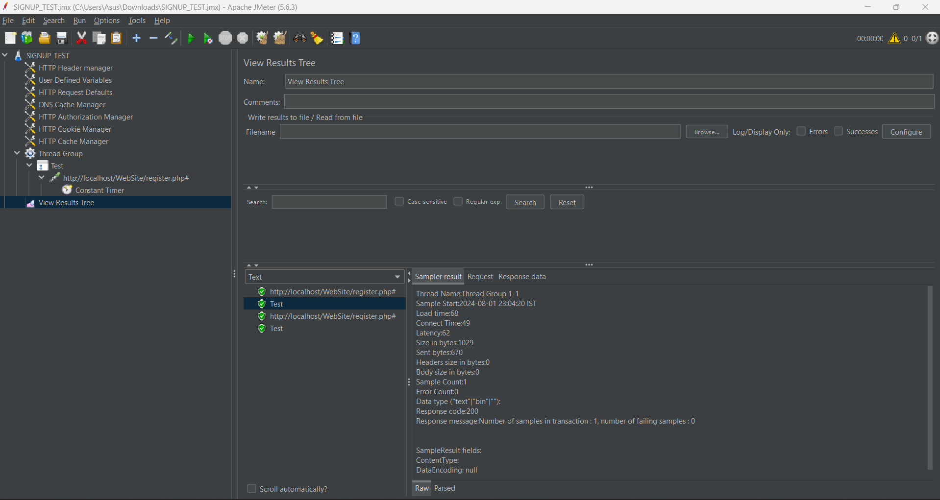

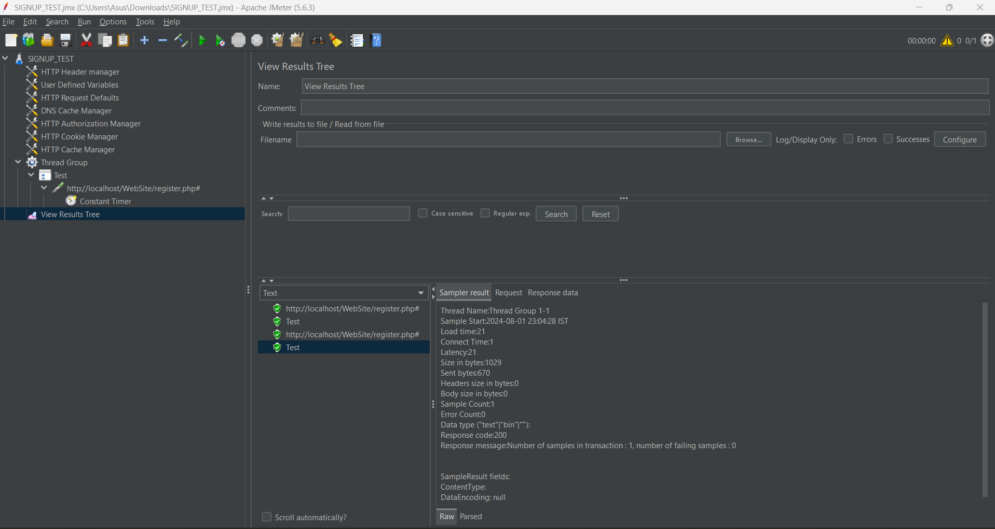

**Test Summary :**

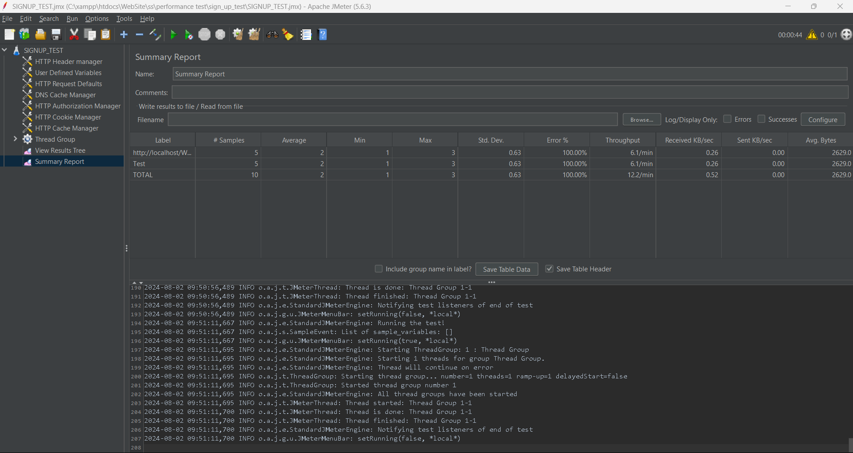

**Git Repository Link :**